
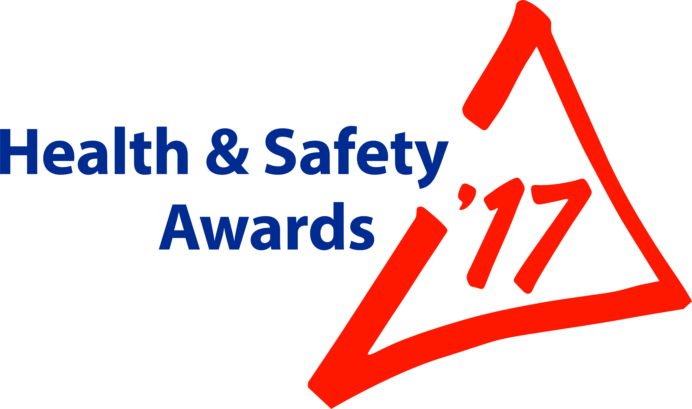
ENTRY FORM
ONLY FOR:
Contractors’ Safety

To enter one of the other categories, download the relevant form from Safequarry.com


Criteria for: “Contractors’ Safety” Entries:

The BACMI Trophy will be awarded to the site/company/organisation that clearly demonstrates a commitment that has resulted in the most improved contractor safety and/or occupational health, through an individual initiative or combination of initiatives.

Your submission should describe initiatives taken, by you as a Client, OR as a Contractor, OR jointly, to improve contractor safety in your organisation or individual site.

Here are just a few examples of what you might consider in your entry (this list is not exhaustive):
- Approach taken in the selection and monitoring of contractors
- Active monitoring of contractor safety and implementing lessons learned
- Efficient use of MPQC-SPA Contractor Safety passport system to the advantage of Contractor and Client
- How you assess the competence of contractors, sub-contractors and agency workers
- Jointly reducing an identified risk; Jointly providing safer and/or healthier services

Judges will be looking for your submissions to clearly define:
- What you have done
- Reasons for undertaking the initiative
- The process you followed from concept to implementation
- Who was actively involved
- What was the outcome; Are there ‘before’ & ‘after’ monitoring results
- What was particularly new or innovative or evolutionary

Judges will also be looking for those ideas that demonstrate a clear improvement in contractor safety and how those ideas may be readily transferred within and beyond the mineral products industry.
Company Name |  |  |  | Open to all: MPA members; & non-members  Maximum 16 entries overall, per Company  Email this form, attaching photos+captions to: hsawards@mineralproducts.org  BEFORE entering, search www.Safequarry.com for previous similar entries. Your entry needs to be a new idea or innovation, or at least a significant improvement of an existing idea.
Unit Name + Postcode
(where entry will be seen by Judges)
Address for correspondence (including post code)
Contact for MPA | Name |  |  | Site Manager  (if different person from ‘Contact’) | Name
Contact for MPA | Email |  |  | Site Manager  (if different person from ‘Contact’) | Email
Contact for MPA | Mobile |  |  | Site Manager  (if different person from ‘Contact’) | Mobile
Entry Ref. No. |  |  | Shortly AFTER you submit your Entry, MPA will supply you with a  unique Reference Number, to be quoted in any further correspondence

Title of your Entry
(15 words max.)

Brief Description; and Benefits following introduction: (suggested maximum: 500 words)

Photographs: 6 high quality images (‘before’ and ‘after’ photographs, if possible)
Attach photographs to your email that you send to MPA to accompany this entry.
Your email to include captions making it clear which caption belongs to which photo.
Please do not embed photos in a ‘Word’ document; image files ONLY (e.g. “.jpg” Max file size of 5Mb)

Recognition of Individuals (Optional)  Employees, hauliers, contractors, who have “gone the extra mile” to make this industry even safer and healthier. Your nominee MUST be connected with this entry. | Name & Job Title (ONE NAME ONLY):
 | Brief Summary of REASONS for nomination:

** Entry Deadline 7th April 2017 **

Submit your Entry | Attach this completed form and your photos to an email  Send to: hsawards@mineralproducts.org

