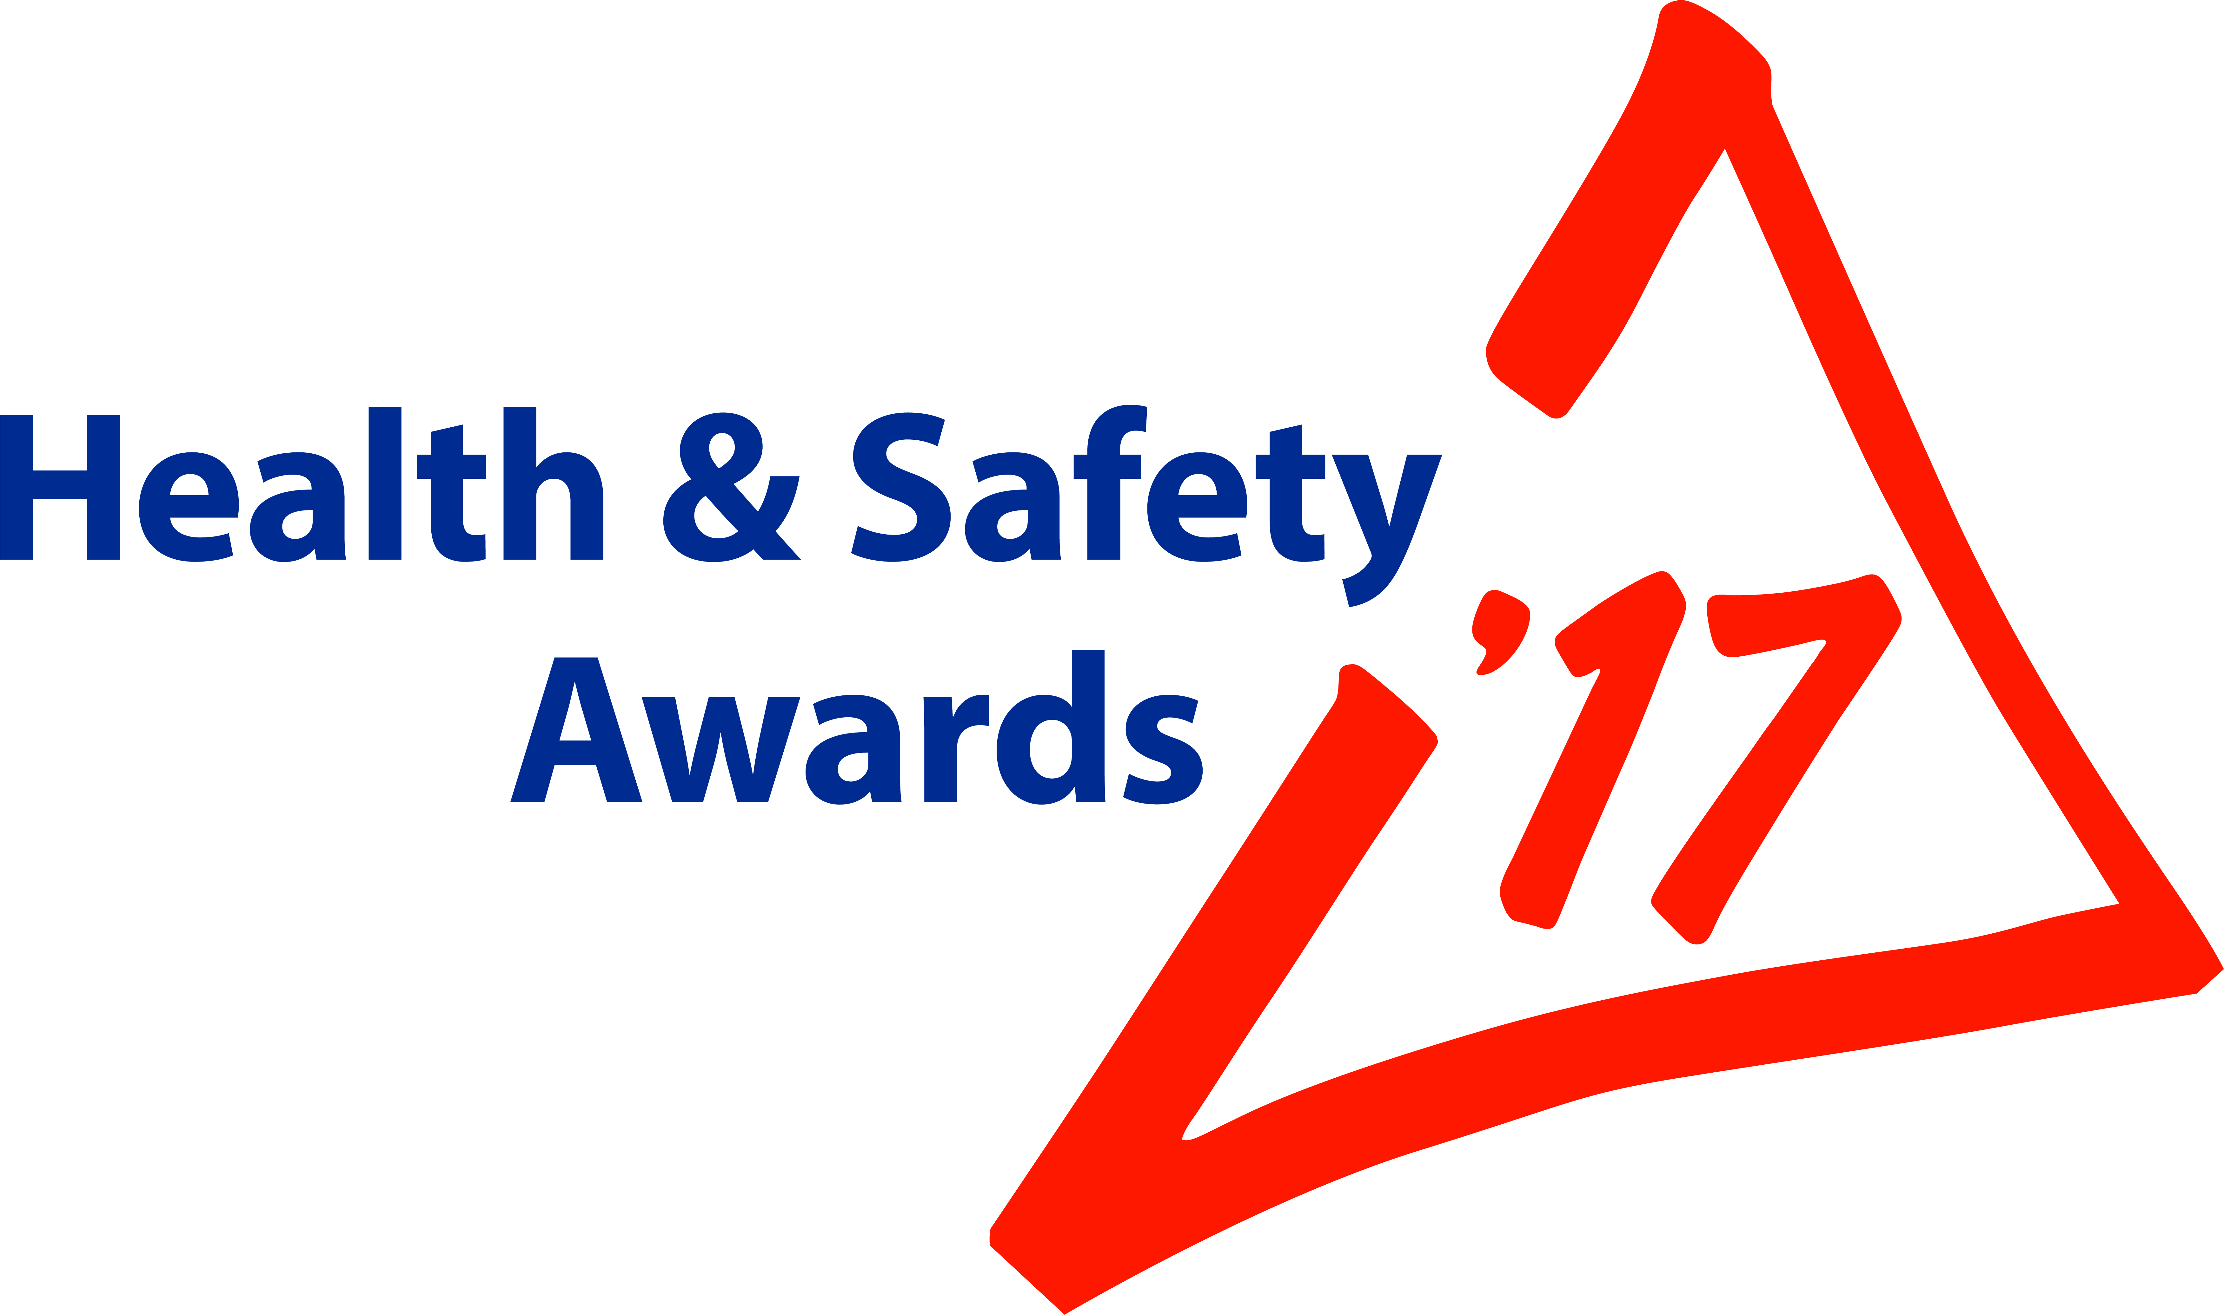

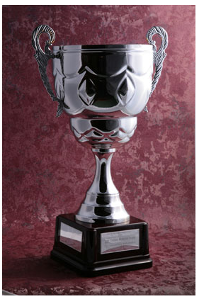

John Crabbe Trophy Questionnaire 2017

Dear Member,

The MPA Health & Safety Committee has decided to REVISE this Questionnaire to reflect the continuing issues of ‘Worker Involvement’; ‘Leadership & Engagement’; and ‘Management of Contractors’ – in addition to ‘Health, Stress and Wellbeing’ ‘Health and Safety Performance’.

Eligibility criteria remain unchanged:

- Must be an MPA/BP producer member or affiliated producer member.
- Must have had no fatalities where the member has been or could be proved culpable since 31 May 2016
- Have an LTI Frequency Rate below 1.8 as calculated by MPA for the 12 months until 30 June 2017
- Submit H&S data to MPA/BP in a timely fashion

Entering is straightforward. Simply complete the table below and forward to this email by noon on Monday 5th SEPTEMBER 2016 to: kevin.stevens@mineralproducts.org

In order to be considered for the John Crabbe Trophy 2017, you are requested to identify and provide evidence as to the practical measures that you have implemented on the ground (not written management systems) to address the following four topics:

Topic | Description | Your Response  MAX: 250 words (1 page) per topic  Type directly in boxes below; email to:  kevin.stevens@mineralproducts.org
1.  HEALTH, STRESS  AND  WELLBEING | Health, Stress and Wellbeing are subjects of significant relevance to today’s mineral products industry.  Identify positive measures that your Company takes, supported by any available evidence, to ensure that:  - Occupational Health is given adequate coverage  - Stress is a manageable issue for your company and its workers.  - Staff and Operatives’ well-being is taken seriously and handled effectively by operational management.
2.  WORKER INVOLVEMENT | Worker Involvement is one of the keys to optimising overall company/site performance.  What positive actions have you taken to:  - Train your employees appropriately?  - What evidence can you provide as to the genuine effectiveness of measures that you have introduced to promote worker involvement?
3.  LEADERSHIP and ENGAGEMENT | Leadership and Engagement are issues of fundamental importance to developing cultural and behavioural aspects of occupational health & safety.  Apart from paper based systems, what practical measures have you taken that have influenced the way your company or site is managed? (Including evidence in your response will be to your advantage)
4.  MANAGEMENT of CONTRACTORS | Management of Contractors. MPA’s H&S statistics, overall, show contractors to be at disproportionate risk of injury, when compared to direct employees.  Provide examples of positive measures that you have taken to:  - influence the healthy & safe behaviour of contractors  - develop genuine two-way trust between your employees and your contractors  Including evidence will be to your advantage.

We look forward to hearing from you and hope that will join us on the day in any event.

‘MPA H&S Conference & Awards’ event on Thursday 2 November 2017 at 30 Euston Square London.

Reservations for the MPA Health & Safety Conference and Awards 2017 can be made by contacting: mary.burling@mineralproducts.org

