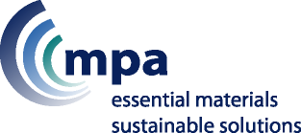
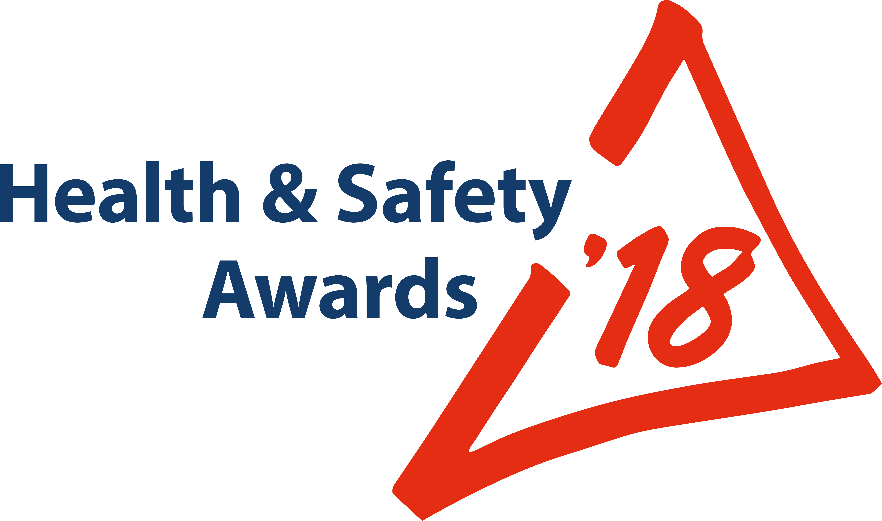
ENTRY FORM
ONLY FOR:
Occupational Health and Well-Being

To enter one of the other categories, download the relevant form from Safequarry.com

Criteria for: “Occupational Health and Well-Being” Entries:

The Wimpey Minerals Trophy will be presented to the site/company/organisation that can demonstrate where innovative or evolutionary idea(s) are having the most beneficial impact on the health and/or well-being of all or a particular group of workers, and/or contractors, where appropriate.

This impact should be related to the elimination, or reduction, of a significant workplace health risk. Alternatively, other workplace changes which have had a significant impact on the health/well-being of the workforce (e.g. through reduction of sickness absence; rehabilitation; job adjustment and managing employees back into work; good health/lifestyle initiatives) will also be considered.

Some examples or combinations may include (there may be others):
- Health promotion and education
- Automation of a process
- Personal health development and review system
- Recognition and managing stress

Judges will be looking for your submissions to clearly define:
- What you have done
- The reasons for undertaking the initiative
- The process you followed from concept to implementation
- Who was actively involved
- What was the outcome; Are there ‘before’ & ‘after’ monitoring results
- What was particularly new or innovative or evolutionary

Judges will also be looking for organisations that have gone that extra mile to embed Occupational Health and Wellbeing into their business using the initiatives they have identified. Judges will similarly be looking how those ideas may be readily transferred within and beyond the mineral products industry.
Company Name |  |  |  | Open to all: MPA members; & non-members  Maximum 16 entries overall, per Company  Email this form, attaching photos+captions to: hsawards@mineralproducts.org  BEFORE entering, search www.Safequarry.com for previous similar entries. Your entry needs to be a new idea or innovation, or at least a significant improvement of an existing idea.
Unit Name + Postcode
(where entry will be seen by Judges)
Address for correspondence (including post code)
Contact for MPA | Name |  |  | Site Manager  (if different person from ‘Contact’) | Name
Contact for MPA | Email |  |  | Site Manager  (if different person from ‘Contact’) | Email
Contact for MPA | Mobile |  |  | Site Manager  (if different person from ‘Contact’) | Mobile
Entry Ref. No. |  |  | Shortly AFTER you submit your Entry, MPA will supply you with a  unique Reference Number, to be quoted in any further correspondence

Title of your Entry
(15 words max.)

Brief Description; and Benefits following introduction: (suggested maximum: 500 words)

Photographs: 6 high quality images (‘before’ and ‘after’ photographs, if possible)
Attach photographs to your email that you send to MPA to accompany this entry.
Your email to include captions making it clear which caption belongs to which photo.
Please do not embed photos in a ‘Word’ document; image files ONLY (e.g. “.jpg” Max file size of 5Mb)

Recognition of Individuals (Optional)  Employees, hauliers, contractors, who have “gone the extra mile” to make this industry even safer and healthier. Your nominee MUST be connected with this entry. | Name & Job Title (ONE NAME ONLY):
 | Brief Summary of REASONS for nomination:

** Entry Deadline 7th April 2018 **

Submit your Entry | Attach this completed form and your photos to an email  Send to: hsawards@mineralproducts.org

