Topic entry (tick boxes that are applicable) 1 2 3 4 5 6 7 8
Entry number (MPA Ref) | 22019
Title of Entry | Raising awareness of customers to dangers of on- site vehicle movements
Name of Company | Suttle Stone Quarries
Location | Mannings Heath Depot
Video (if yes, please include URL for video) | No
Other resource (if yes, please include description) | Type here
Fatal Theme (tick boxes that are applicable) 1 2 3 4 5 6
BACKGROUND
Mannings Heath Depot is a busy stone collection and waste ‘tip off’ recycling depot, used by numerous builders usually driving flatbed style ‘Transit’ tippers. Normally between 300-400 vehicles will use the site daily.
The depot is restricted in terms of space so customer vehicles and loading shovels are required to share the same space in some areas of the site.
Over the last 5 years there has been an average of one incident per year where a customer’s vehicle has been damaged when driving behind a reversing loading shovel.
Damage is ‘light’ due to the slow speeds involved but still not wanted!
Employees also log ‘Close Calls’ with customers driving behind shovels via our internal close call reporting process. These are followed up at the time with the customer however due to the high level of customers passing through the site it is difficult to get this message to all customers
MANAGEMENT OF PROCESS
The sites employees led by site manager Andy McCuish decided to look again at possible ways to manage the traffic and educate customers as to the danger a reversing loading shovel can pose.
Two ideas which were felt could have a positive impact on the situation were agreed and implemented.
1 – The installation of a barrier at the entrance to the loading area. During particularly busy times the barrier can be held in the closed position, holding back vehicles while the loading shovel loads customers that have already entered the loading area.
2- Place a large pictorial sign by the barrier which warns drivers against driving behind loading shovels. This sign is fitted with blue strobe lights which turn on when a vehicle approaches the barrier.
The same sign has been fitted to the rear of each of the two shovels that operate in the yard.
BENEFITS
The barrier is used to hold back traffic at busy times, reducing congestion in the loading area. It is had the added benefit of slowing down / stopping customers and making them think ‘safety’ before entering the loading area. It also eases the pressure on the shovel driver as there are less vehicles that the driver needs to be aware of in the loading area.

The signs have had an early positive impact as a number of customers are now waiting to gain an ‘ok’ signal from the shovel driver before driving behind the machine or at least giving the shovel a wider berth.

Simple and low cost solutions have a positive impact.
INNOVATION
The use of a barrier at one of our 3 sites is a first and therefore a new idea for us.
Employing signs to educate people is not new. Previous experience of installing warning sites at the site did not have any effect but by removing some signs and installing this large, simple, clear picture with flashing lights is finally having a positive impact.
DEVELOPMENT & TRANSFERABILITY
Signs aren’t new but perhaps fixing them to the back of a loading shovel is and could be transferred to other operators with similar issues.

The signs don’t impede access / operation of the machine and can be quickly removed if required.
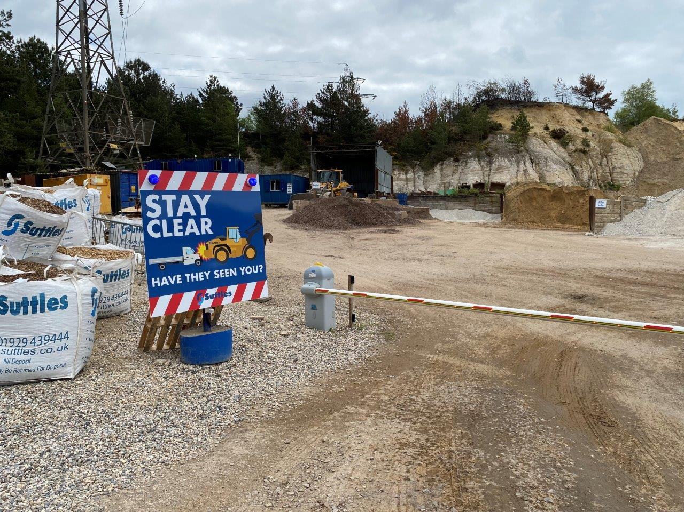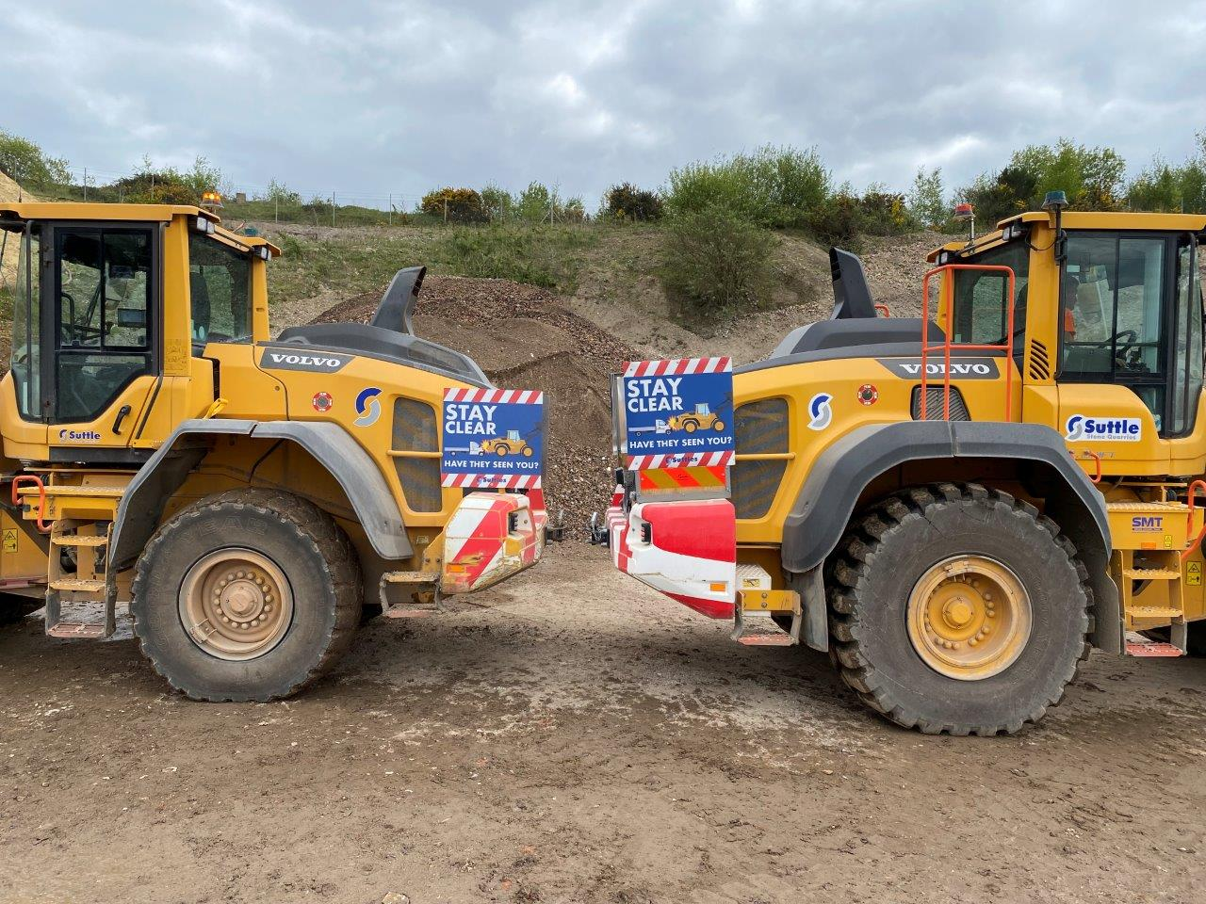
NB if document has embedded images try and include these
If other documents provided say additional information available.

