Topic entry (tick boxes that are applicable) 1 2 3 X 4 5 6 7 8
Entry number (MPA Ref) | 22066
Title of Entry | Admixture Control System
Name of Company | Cemex UK Materials
Location | Aston
Video (if yes, please include URL for video) | No
Other resource (if yes, please include description)
Fatal Theme (tick boxes that are applicable) 1 2 3 X 4 5 6
BACKGROUND
Due to how busy Aston is, we needed to ensure that the admix fill/usage was simplified as much as possible. Previous systems have made the delivery process very messy with spillage inside and outside of the tanks.

The admix delivery drivers have no visible way of seeing what is in the tank. The normal method of filling up the tanks is to put the delivery pipe in the top of the tank and discharge what has been ordered. If the tank can't take the capacity, then the drivers don’t know the tank is full until it overflows into the bund.

MANAGEMENT OF PROCESS
5 x 3500ltr admix tanks with electronic measuring device that are in the batch office.
Auto shut off valves to stop overfilling.

Due to how busy Aston is, we needed to ensure that the admix fill/usage was simplified as much as possible. We have installed external measurement devices so the drivers can see immediately how much is in the tank which allows them to shut off the filling process before it overspills.

Gantry to access the top of the tanks so a weekly/monthly dip check can be carried out.
The system is house guttering, rope, x2 cistern floats (weighted one end) and a measured pole.
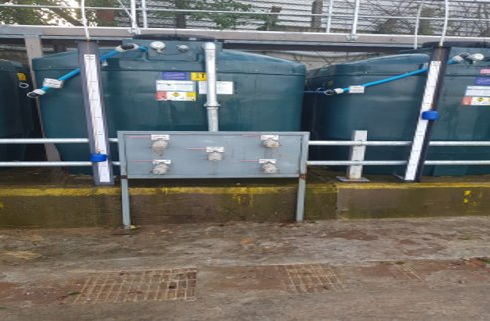

BENEFITS
- Ease of knowing for delivery drivers how much is in the tank so they do not have to rely on the auto shut off valves.
- Plant manager can see from his office his stocks via the electronic plug in devices
- Cleaner environment
- Complying with the site permit
- Quicker reference for ordering
- Create a safe and efficient way of the delivery of admix into the tanks
- One station fill up point that feeds all the tanks to reduce vehicle movements
- Tanks would stay clean with no build-up of admix in the bunds keeping them 100% efficient.

INNOVATION
The complete system eliminates spillage of admixtures or overfilling of tanks, this means that delivery drivers do not have to climb over tanks with pipework and walk backwards and forwards between deliveries, as they can clearly see from the outside how much product is left in the tank.

This system was discussed by the team and the innovative solution was achieved by their approach and planning.

The old system that we have on most ready-mix plants can now be designed to suit all other ready-mix plants in the UK.
DEVELOPMENT & TRANSFERABILITY
This is now being rolled out as ‘best practice’ and we are currently in the process of replicating on our new and older sites.
It has been shared on LinkedIn and on Cemex internal Ideation system.

We would welcome other companies visiting our site and sharing this best practice.
NB if document has embedded images try and include these
If other documents provided say additional information available.

