Topic entry (tick boxes that are applicable) 1 2 3 4 x 5 6 7 8
Entry number (MPA Ref) | 22017
Title of Entry | Daily Brake testing and Radar systems on concrete plants
Name of Company | Tarmac - North & Scotland Materials
Location | Yorkshire Concrete Plants
Video (if yes, please include URL for video) | No
Other resource (if yes, please include description) | No
Fatal Theme (tick boxes that are applicable) 1 2 x 3 4 5 6
BACKGROUND
Daily brake testing occurs on site, but ensuring consistent results required an improvement to the process.
Concrete plants are recognised for their small footprint so having a similar procedure to the mineral extraction business was not possible.
Therefore, a review of the process was undertaken with site personnel including the shovel telematics to agree a suitable speed limit.
The design that was agreed upon is a sign which is 1.4m in length. The shovel approaches in 2nd gear at 15kmph and applies the brakes at the start of the sign, with a requirement for the Shovel to come to a safe Standstill within the 1.4 metre signage area.
A safe operating procedure was written to support the process.
Additionally, the shovels are fitted with radar systems, and these also require testing daily. Again, a review was undertaken and a 4 metre sign in correlation with the 3 detection ranges set within the parameters stipulated by the Sensor Vision Intelligent Warning System.
Independent inspections of both systems are undertaken regularly, however this procedure enables any potential deterioration of the system to be highlighted.
MANAGEMENT OF PROCESS
The Sensor Vision Intelligent Warning System is a robust way of providing an audible and visual warning to a machine operator when approaching a hazard.

Due to the Ergonomics and limited footprint normally associated with a Concrete Plant, along with the frequent requirement to reverse within a restricted area, this is an extremely important piece of equipment to ensure Mobile Plant can be operated in a safe manner.

An essential aspect when using this type of equipment is ensuring that it is functioning correctly at all times.

Additionally, PUWER regulations states that equipment provided for use at work is safe for use, maintained in a safe condition and inspected to ensure it is correctly installed and does not subsequently deteriorate.

The 6 Weekly Brake Testing and Annual VMS Inspections carried out by recognised approved contractors ensures that compliance is achieved, however this did not account for performance of the systems between inspections.

The procedures implemented, and the visual aids in place to support this, ensure that safety control systems are operating correctly prior to the Mobile Plant being used.

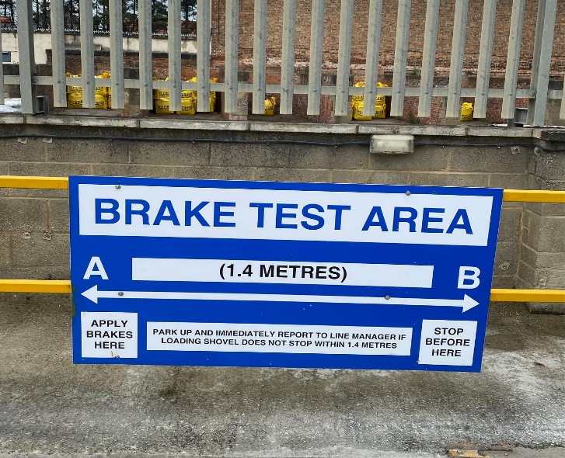
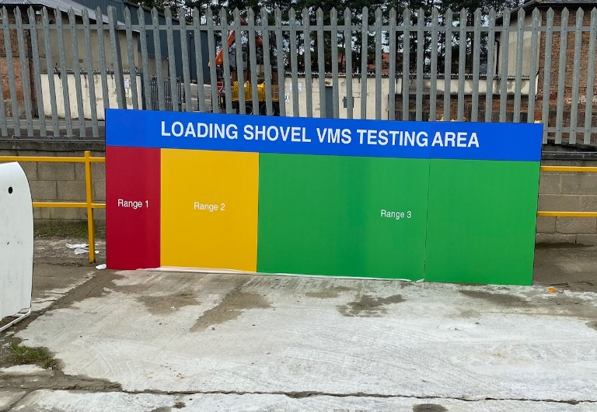
BENEFITS
A consistent approach to the control procedures implemented across Tarmac Readymix sites in relation to Mobile Plant Operations that would identify any deterioration in these controls, ensures that Operators can be confident that the machines are operating effectively
INNOVATION
DEVELOPMENT & TRANSFERABILITY
Other sites across the Tarmac North and Scotland concrete business have adopted this system
NB if document has embedded images try and include these
If other documents provided say additional information available.

