Topic entry (tick boxes that are applicable) 1 2 3 4 5 6 7 8 X
Entry number (MPA Ref) | 22003
Title of Entry | Mobile Apps for Daily Safety Checks
Name of Company | Sewells Reservoir Construction Limited
Location | Highwood Quarry
Video (if yes, please include URL for video) | No
Other resource (if yes, please include description) | 1 attachment
Fatal Theme (tick boxes that are applicable) 1 X 2 3 4 5 X 6
BACKGROUND
Getting operators to reliably fill out and send in the reports of their daily safety checks was problematic. Operators were not handing in paper-based sheets to the weighbridge or site supervisor until the end of each week. These then had to be sent to head office for filling with hours and faults manually transferred onto several spreadsheets for the plant manager to review and organise servicing and repairs.
The resultant delay meant faults might not be rectified for several weeks due to delays in the notification, ordering parts, and arranging the servicing and repairs. These delays potentially increased the operator's and other workers' risk or meant that a machine could be out of action for far longer than it need be.
By improving reporting and resolving of faults the apps have improved maintenance of the mobile plant and reduced the likelihood of (FATAL 1 -) Contact with moving machinery and isolation
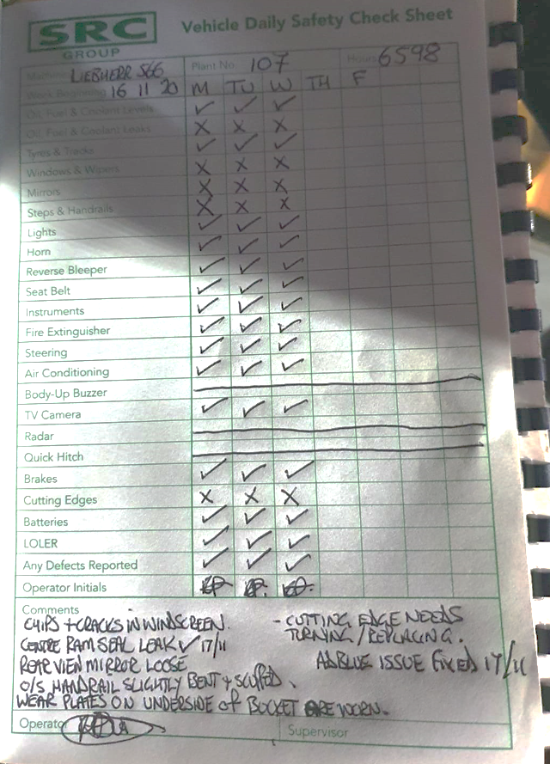

MANAGEMENT OF PROCESS
Discussions and meetings were held between the H&S manager, Plant manager, quarry managers and key plant operators as to the solution's requirements.

The ideal solution for plant operators was instant reporting of daily safety checks that can be submitted on their phone. It should not need good internet to work, not use a lot of data and should work on older devices and OS such as Android or IOS or Windows mobile.

The plant manager needed automatic updating of the plant service database and entry of all faults onto a maintenance planner, allowing the ordering of parts mid-morning and, in some cases, fitting them the same day. Tracking of repair faults digitally also allowed reporting back to manufacturers of common faults and manufacturing defects of machines with evidence to back them up.
Quarry managers needed notification of machine faults to be able to plan work properly and manage staff.

Available apps were not an option due to:
- lack of signal within the sites meant many apps would not work as they needed a stable internet connection,
- licensing restrictions on a set number of devices would be an issue when contractors or agency workers did not log out when leaving site,
- many apps are not cross-platform or mobile compatible, preventing some operators from using their own devices,
- many apps were a one fits all solution and did not allow custom check sheets
It was decided that a custom app was required. Approval was given by the Managing Director for the development which was assigned to and led by the Health and Safety Manager due to previous app experience.

Key operators field-tested the prototype and updated versions until a near final app was created. Additional testing was then carried out by the key operators and management for intuitive functionality, stability, and accuracy of data transfer.

Manuals were created on how to download and use the app allowing operators to be onboarded to the apps use via email, WhatsApp and even text message.

The app empowers plant operators to report issues and defects, knowing that immediate action will be taken to resolve issues. They enable managers to check the compliance of operators and resolution of problems that could affect Unsafe Working Conditions.

BENEFITS
The roll-out of the apps has seen a significant increase in operators' compliance, completing safety checks every day. Plant management has seen an increase in the reporting of minor faults that, through speedy resolution, has reduced the number of major plant failures resulting in plant downtime. In addition, there has also been a reduction in the number of dangerous occurrences where faults or non-notified damage are the cause.

Mobile apps for checks are not a new concept, but a suite of apps that can be used without a mobile signal for the specified plant is a dramatic improvement that has enabled us to resolve issues with greater efficiency, improving the safety of workers and efficiency of group operations.

In the last 30 days alone, 650 daily safety checks have been carried out, and nearly 60 fault logs cleared. This represents a significant improvement in compliance and efficiency with fewer breakdowns and increased productivity with machines not having to be taken out of service.

Minor faults such as cracked mirrors and faulty beacons are being fixed, improving the safety of the work environment which, in conjunction with other initiatives has helped to reduce the plant/vehicle contact on sites.
INNOVATION
The innovation of the original app has resolved the original issue improving worker buy-in that daily safety checks are not just a “tick box” exercise and that reporting of issues leads to timely resolution of these issues resulting in a safer work environment for everyone with improved efficiency.

The creation of mobile apps is new for the organisation and the transfer and updating of files through automation.

DEVELOPMENT & TRANSFERABILITY
The success of the first app opened up the path to create a suite of apps shown below:

- Excavation Inspection Report
- Crusher and Screener Daily Safety Check
- BDU & Tripper Daily Safety Check
- Ecobloc Daily Safety Check
- Van Daily Safety Check

Additional apps can be developed as the need arises to improve Health and Safety or efficiency of the organisation.
Images of the app
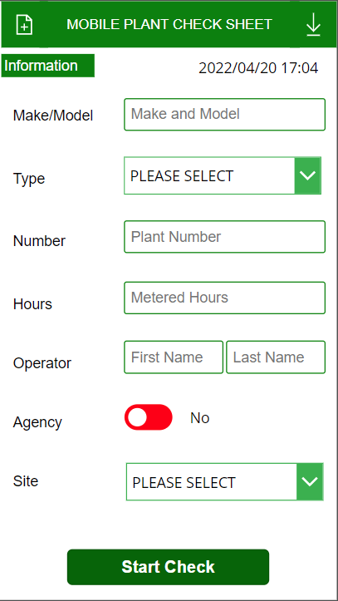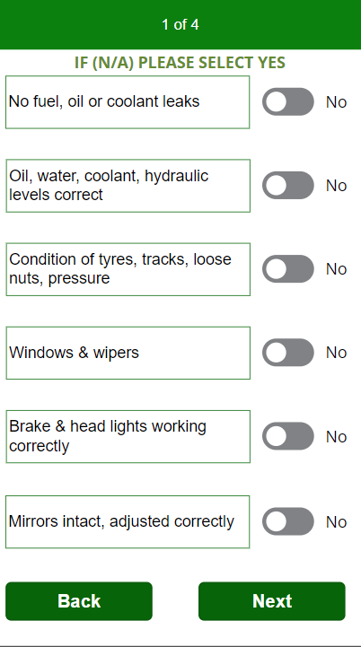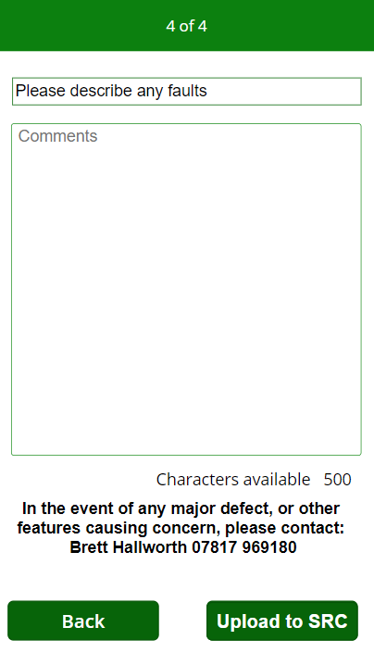
Automated faults list creation and update from the app
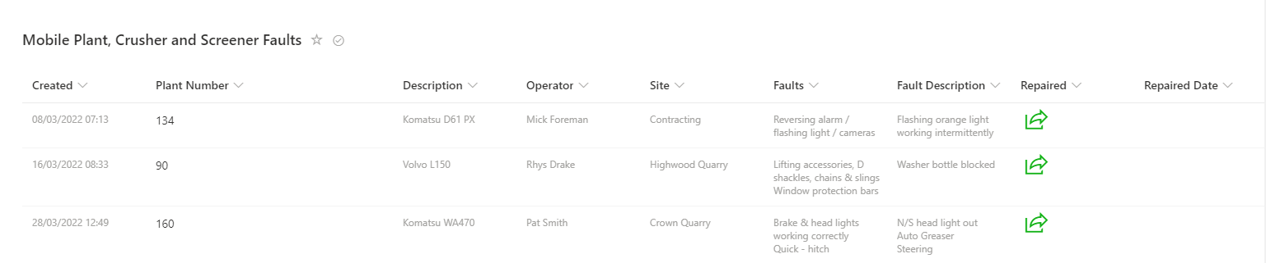
Automated service and check sheets with data from the app
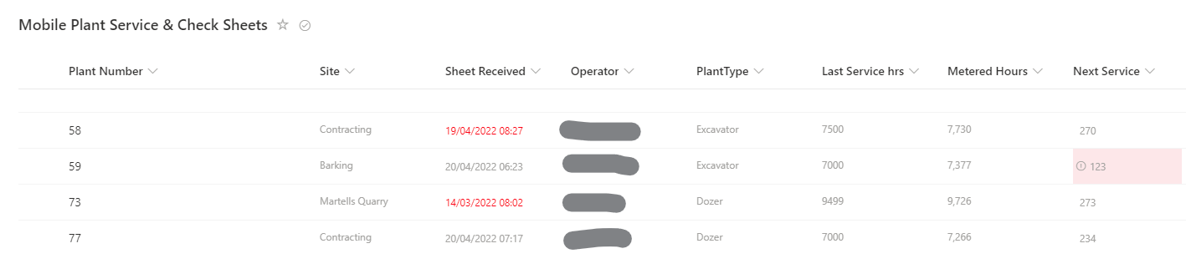

Automated daily emails of app submittals to site managers and plant managers
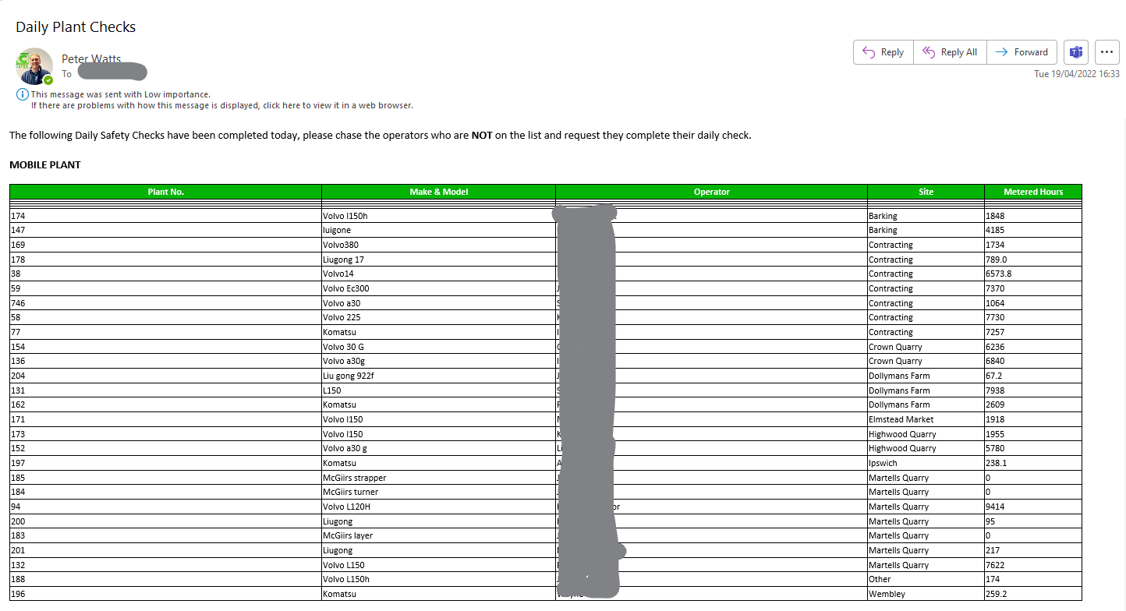

Analytics of app usage allowing monitoring of compliance over time
