Respirable Crystalline Silica – Using Disposable RPE
The UK Health and Safety Laboratory recently tested ten models of disposable dust mask (FFP3 filtering facepiece respirators). The models were from different manufacturers and were selected to cover a range of different designs and prices. The findings were as follows;
- Five of the models passed all tests with no faults or failures

- Two of the models each had an isolated fault on a single sample
- one was very serious: a folded over exhalation valve flap, rendering the mask ineffective.
- the other was a pinhole through the filtering material, which increased the leakage through the filtering material to slightly above the permitted level

- Three of the models tested had multiple faults
- Of one particular model, half the samples failed the exhalation breathing test. This would not directly affect the protection offered, but could be less comfortable for the wearer.
- Of one particular model, two thirds failed to meet the filter penetration test. In the workplace, this could lead to reduced protection (two of these samples were also found to have visible splits in the filtering material).
- One particular model had numerous faults; one sample had a missing exhalation valve; two samples had holes through the heat-welds holding the straps in place; one sample was excessively crumpled. More than a quarter of the samples examined were found to have a fault that could affect performance.

What can we learn from the study and expert advice about disposable dust masks?
Respiratory Protective Equipment (RPE) is the last resort when it comes to protecting workers from dust exposure. The hierarchy of control below, sets out the order to follow when planning to reduce risk. Do not simply jump to the easiest control measure to implement!
Elimination – remove the hazard or the hazardous activity;
Substitution – substitute a safer alternative e.g. use of materials with lower dust/Respirable Crystalline Silica levels or a different process;
Separation/isolation - isolate or separate people from the hazard by use of barriers, distance or time e.g. change the way people work.
Engineering controls - redesign or modify tools or equipment, isolate people from the hazard (EESI… enclose, extract, suppress it)
Administrative controls - use training, rules and procedures to reduce the risk
Respiratory Protective Equipment - provide fit-for-purpose protective equipment

Advice on reducing dust/RCS levels can be found at the Safe Quarry.com, Quarry Partnership Team Dust Initiative, the HSE dust hub and NEPSI
It is important to select RPE that gives the correct level of protection. Employees need to be trained in its use, and it needs to be properly maintained and stored (e.g. not on top of a locker where dust can accumulate). HSE has produced guidance on the use and selection of RPE in the workplace. Understand the markings;
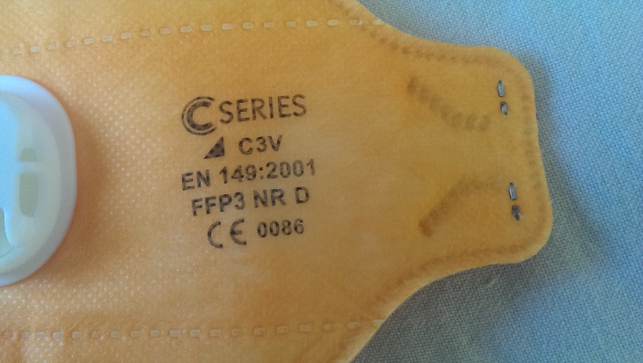
EN 149: 2001: The standard for disposable respirators.
FFP3: Filtering Facepiece 3, the highest level of protection and that normally used in the industry (NR: Not Reusable, D: meets clogging resistance requirements)
CE: Manufacturers declaration that mask complies with relevant standards (0086 Accreditation Body)
(model chosen solely to demonstrate markings)
If fitted correctly FFP3 dust masks offer a protection factor of 40, whereas; FFP2 and FFP1 offer protection factors of only 20 and 10 respectively. So called nuisance dust masks with only one strap and no CE marking have no place in the industry. Dispose of masks marked NR after a single shift (8 hours).

The performance of a tight-fitting facepiece (full face mask, half mask, or disposable mask), relies heavily on the quality of fit to the wearer’s face. An inadequate fit significantly reduces the protection provided, as does the presence of facial hair/stubble in the region of the face seal. One size does not fit all, and consequently, it is a requirement that face fit testing is included as an integral part of an RPE programme for mask-based devices.
The British Safety Industry Federation, along with the HSE and other industry stakeholders have developed a competency scheme for Fit Test Providers. Whilst the Fit2Fit scheme is not compulsory and employers are free to take other action to comply with the law, HSE has confirmed that following the scheme will be enough to demonstrate good practice.
Facefit testing is often confused with pre-use checks. Facefit testing is necessary to ensure that a good fit is capable of being achieved with a particular type of RPE for an individual.

Pre-use checks should be carried out to ensure that individual masks are not defective and have been put on correctly. A number of the failings found in the HSL study would have been picked up by appropriate pre-use checks e.g. by checking for splits and that; exhalation valves are operable; masks are not crumpled; filter material is not roughened/damaged in some way; nose pieces and straps are operable. Rotate your stocks and check for any use by date.
Pre-use checks will vary according to the type of dust mask selected and manufacturer’s instructions should be followed. Often information accompanies the dust mask, if not ask your supplier for advice. 3m have produced a range of useful videos which can be found at https://www.youtube.com/watch?v=tNXRbcqPExc and they have also shared the poster overleaf.

