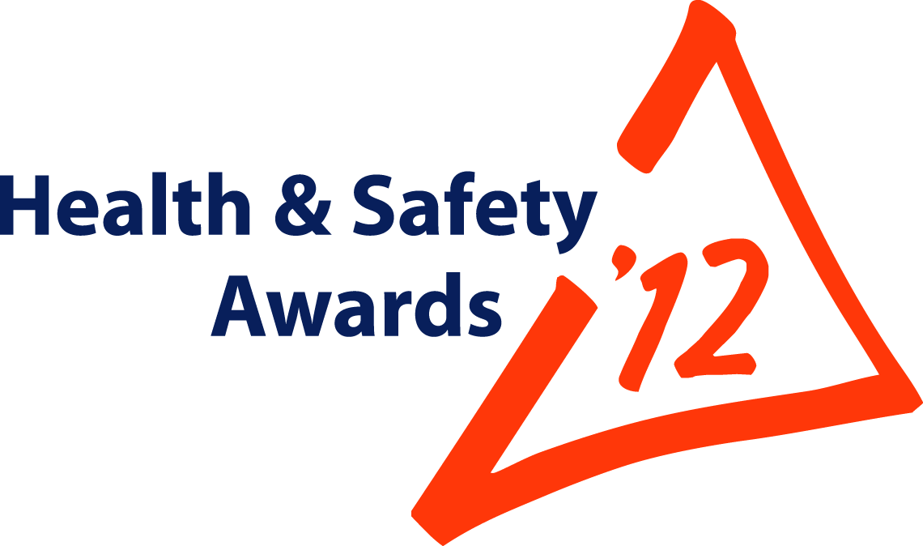


Entry Form

Open to all: MPA members;
non-MPA*companies

* Trophies restricted to MPA members UNLESS,
entry submitted jointly with an MPA Member

Maximum 15 entries per Company

Entry Reference No: |  | For MPA Office use only. You will be advised of your unique Entry Number, to be quoted in any correspondence

Page 2 of 7

Topic  (Brief guidance on Page 5) Tick or mark ‘X’ in ONE box only  Your company can submit a maximum of 15 entries | Occupational Good Health
 | LGVs/HGVs and all other company vehicles; Driver Safety/Public Safety
 | Contractors Safety
Worker Involvement
X
 | Bitumen; Asphalt; Contract Surfacing:- Promoting Safer Behaviour
 | You may enter here only IF your subject fits none of the above | Engineering Initiatives
 |  | Leadership; Training; Management Systems Initiatives

Instructions | MPA prefers your entry to be submitted online via www.Safequarry.com.  Alternatively, complete this form and attach the form and your photos to an email and send to: hsawards@mineralproducts.org.  BEFORE entering, search www.Safequarry.com for previous similar entries. Your entry needs to be a new idea or a significant improvement of an existing idea.

Company Name | Tarmac, Buxton Lime and Cement
Unit Name (where entry is) | Tunstead Quarry
Address for correspondence (including post code) | Tarmac Limited,  Tunstead House,  Buxton,  Derbyshire  SK17 8TG
Person To Be Contacted Name | Martin Clarke
Email | Martin.Clarke@tarmac.co.uk
Telephone Number | 01298768144

Recognition of Individuals (Optional)  Employees, hauliers, contractors, who have “gone the extra mile” to make this industry even safer and healthier. Person(s) MUST be connected with entry. | C.A.T.S. Team :- I Barnes (Facilitator & Lead), K Beadman, S Bagshaw, P Hobson, P Proudlove, S Page, G Higgins, J Martyn, M Fisher, M Grindy, K Robinson, M Champion, V O’Hora
 | The C.A.T.S. team, are a group of “workmates” that have developed a systematic behavioral safety process that is fully owned, managed and refined by the workforce.

Page 3 of 7

Entry Deadline | Thursday 17 May 2012
Title of your Entry | C.A.T.S. – Changing Awareness Towards Safety

Brief description
Feedback from an independent cultural survey identified opportunities for involving the workforce as the biggest enabler to improving our safety culture by focussing on behavioural safety.
What did we do?
A team of workforce colleagues (employees and regular contractors – all operatives) developed their own “Behavioural Observation” process. This was owned led and managed at a “shop floor” level, with no management or supervisor involvement other than facilitation of the process. It engages the entire workforce and is completely anonymous. The process is built on trust & engagement!
The team developed a high level process, which they communicated to the entire workforce through various media, such as briefings, newsletters and noticeboard information. The team also asked for volunteers from the workforce to develop a Steering Team that would develop, implement and then manage the process.
From this the C.A.T.S. (Changing Awareness Towards Safety) team were born.
C.A.T.S. Vision Statement
“C.A.T.S Vision is to create a culture where EVERYONE’S safety is the first thought, focusing on behaviours to improve overall safety and awareness to ultimately achieve an incident free workplace.”
Process Description
Observe – Feedback – Collect Data – Analyse Data – Improve – Feedback
Observations
The corner stone of the entire process are observations. The observers have been trained by their own facilitator to look for and understand both safe and at risk behaviours. To help them do this, the C.A.T.S. steering committee analysed all accidents from the previous four years and identified “at risk” behaviours that had contributed to them. The analysis helped the team develop their own list of “critical behaviours” and this is what they look for when carrying out an observation.
After the observation the observer provides feedback on both safe and any risk behaviours they have seen, which involves a short two way discussion. The observer captures and records anonymously the feedback from the person observed. The entire process is totally transparent and no names are recorded.
Data collected from the observations is analysed, trended and reported back to the C.A.T.S. Steering Committee. The committee make recommendations to the management teams on where things that encourage at risk behaviour could be changed or improved.
The C.A.T.S. Steering Team
The C.A.T.S Steering Team is made up of 12 workforce volunteers, representing all areas, departments and functions. Each member is a fully trained observer and complete observations each week. The Steering Committee members also have other roles within the team that support the process, i.e. some are responsible for communications, others for training, others for data input etc.

Benefits following introduction | The main benefits experienced by both the team and the business are:  - Culture Change – Workmates looking out for each other and ultimately reducing injuries and near hits!  - Ownership by the group – Safety is demonstrably the responsibility of everyone – I look out for my colleagues  - Engagement – if something is not correct, I have the confidence, knowledge and commitment to challenge either my workmate or manager  - Management by fact - accurate and real data to demonstrate what needs to be done – helps to reduce “opinion based” decision making  - Focus on things “below the Iceberg” that current systems can’t fully address - behavioural safety is a key to improvement and this process brings on board many additional eyes and ears  - Credibility – workmate to workmate interventions, I am prepared to listen to my colleague and act upon their advice  - No blame – no names reported hence no blame – the only statistics cover the types of interventions and their outcomes, no individuals are identified.
Photographs with captions (‘before’ and ‘after’ photographs, if possible) Place photographs below for illustration purposes. Attach high quality photographs to email accompanying this entry or better still apply online via www.Safequarry.com
CATS team – developing “peer to peer” observation process, employees and contractors representing a range of business areas within Buxton Lime and Cement

Behavioural Safety timeline from concept to implementation developed by the CATS team

Observation reporting form developed by the CATS team and used for recording observations

MORE PHOTOGRAPHS CAN BE SUBMITTED IF BENEFICIAL TO YOUR ENTRY

Page 7 of 7

What happens next?

- Entries will be acknowledged; you will be advised of your unique Entry Reference Number which you will need to quote if contacting the MPA, or when making visit arrangements
- Your entry may be switched to another category at the Judges’ ultimate discretion
- Your entry will be read by the appropriate MPA Assessors and Judges who will produce shortlists. The importance of clear description, supported by GOOD QUALITY photographs, is emphasised.
- Judges will visit or telephone shortlisted entrants, where deemed necessary.
- Judges’ decisions are final.

Scheme Rules and Guidance Notes - The 2012 Scheme is open to all
The Mineral Products Association’s annual Awards Scheme is open to all with an interest in health & safety. MPA welcomes entries from every organization in the supply chain. If you are a non-Member and wish your initiative or good idea to be considered for a Trophy, YOU NEED TO ENTER JOINTLY WITH AN MPA MEMBER.

To take advantage of this opportunity via the ONLINE facility, you need to REGISTER on www.Safequarry.com – this will take 90 seconds of your time!


Log into www.Safequarry.com
And click this gold button . . . . . . . . .

. . . . . . . . . . . . . . . . Strict Deadline: 17 May 2012 . . . . . . . . . . . . . .

Points to consider include:  If your Entry is selected for a Judging Visit, the Judge will want to “walk the talk” and discuss your Entry with Operatives, as well as Managers. | - Indicators of commitment by your company
 | - Description of efforts to influence behavioural aspects
 | - Give credit to whoever came up with the good ideas
 | - Effectiveness of control measures (engineering/management)
 | - Method(s) and effectiveness of monitoring system
 | - Problem areas: identification and priorities for action
 | - State actual levels of recorded improvement, if possible
 | - Evidence that existing good practice has been taken on board
 | - Evidence that specific legislation/guidance is understood
 | - Evidence that all relevant workers taken into account
 | - Briefly explain how you communicated the benefits to others
 | - Involvement and genuine workforce support (incl. Trades Unions, where applicable)
 | - Refer to Safequarry.com
 | - Is your good idea/innovation in regular/routine usage?

One of these Scheme trophies could be yours for a year . . .

