Entry Reference No: | 36 | For MPA Office use only. You will be advised of your unique Entry Number, to be quoted in any correspondence

Company Name | CEMEX UK Operations
Unit Name (where entry is) | RUGBY CEMENT PLANT
Address for correspondence (including post code) | LAWFORD ROAD,  RUGBY  CV21 2RY
Person To Be Contacted Name | Miguel Lara
Email | miguel.lara@cemex.com
Telephone Number | 01788 557757

Title of your Entry | Cardox Port safety device

Brief description
Cardox tubes are used extensively in cement plants to clear process blockages by the controlled rapid discharge of high pressure CO2 stored in the tube.
Cardox ports are located around several cyclones, chambers and ducts within the kiln pre-heater tower to allow access to inspect and clear build up of material within the process. A port cap is removed to inspect internally for build up and if required, the tube is then inserted, secured by a proprietary system and activated to clear the blockage. However, there have been occasions when the position of the build up has resulted in the flow of process material being diverted so that it immediately flows out of the Cardox port after the cap has been removed. This exposes the operator to a large amount of hot (900C+) flowing material making it difficult to approach the port to replace the cap. Historically, there have been several incidents resulting in injury and also damage to plant. Safe operation was primarily based on the experience of the operator and the effectiveness of his PPE.
Following an incident in 2011 where an employee received minor burns to his hands a review of the risk assessment was conducted which identified that an engineering solution was required to minimise this risk. A safety device was designed in house by the Mechanical team at Rugby plant which allows a cover to be fitted over the Cardox port equipped with a closable spade.
Following successful trials the Rugby plant team requested that CARDOX International provided a similar type of device based on this design.

Benefits following introduction | - The protective device can be fitted before opening the cardox port and enables the operator to quickly close the port from a safe position if the internal process conditions result in hot material flowing out.  - The Cardox port cap required the operator to push the cap into the flow of material and was an awkward job to secure, in some cases, even in normal conditions. The spade can quickly be closed from a position way from the flow of hot meal.  - The safety of the individual doesn’t rely on his experience or PPE factors… or good luck.  - A safe system of work for the inspection of cardox ports has been developed by the pre- heater tower team to include the use of the Cardox port protection device and all operators have been trained and work to this standardised procedure.  - The equipment is now available as a standard tool provided by Cardox.
Photographs with captions (‘before’ and ‘after’ photographs, if possible) Place photographs below for illustration purposes. Attach high quality photographs to email accompanying this entry or better still apply online via www.Safequarry.com

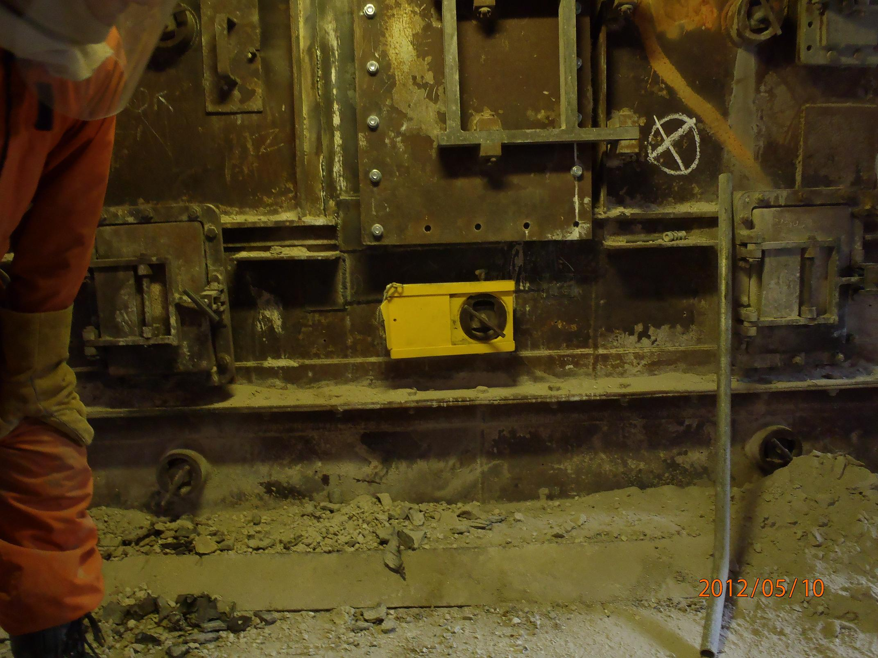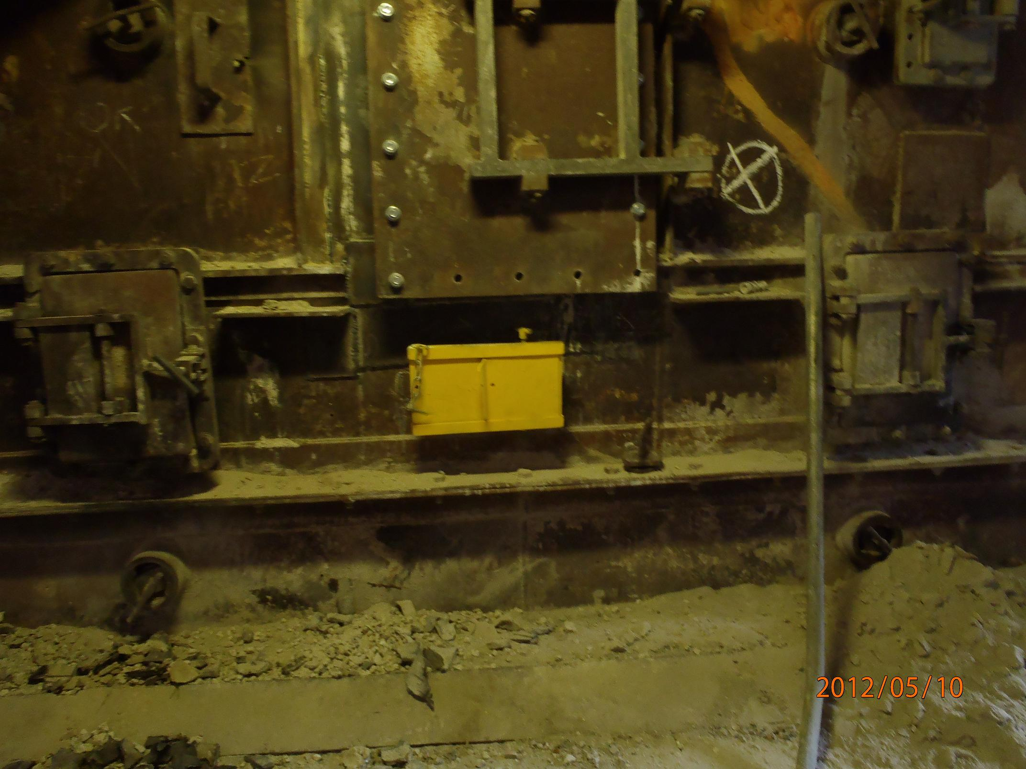
Safety device fitted with Cardox Cap still in place Safety device closed with Cap removed
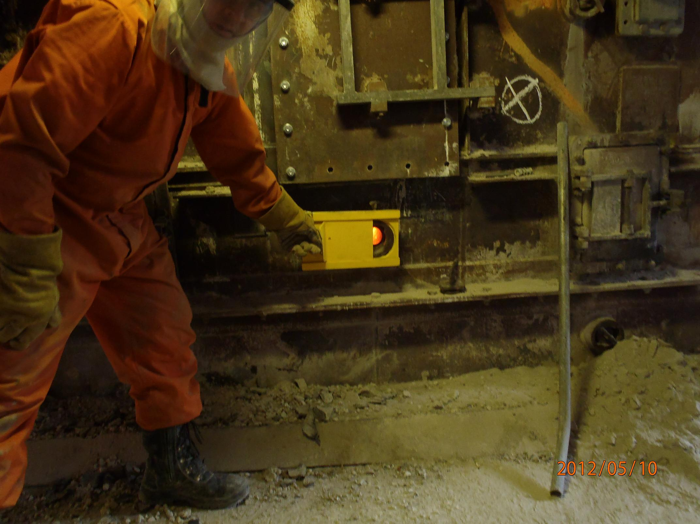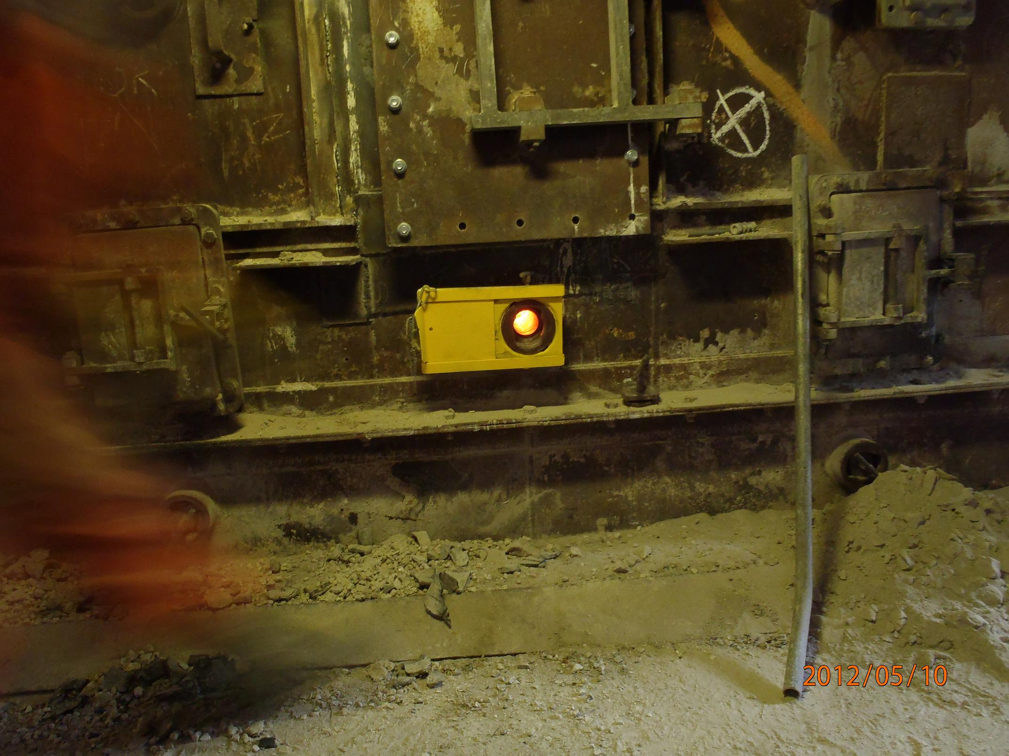
Safety device slides open Safety device open ready for insertion of Cardox unit
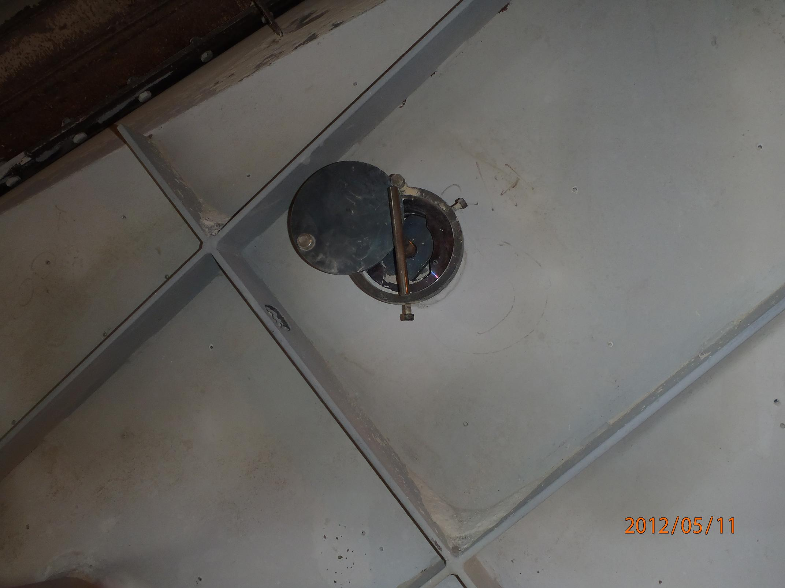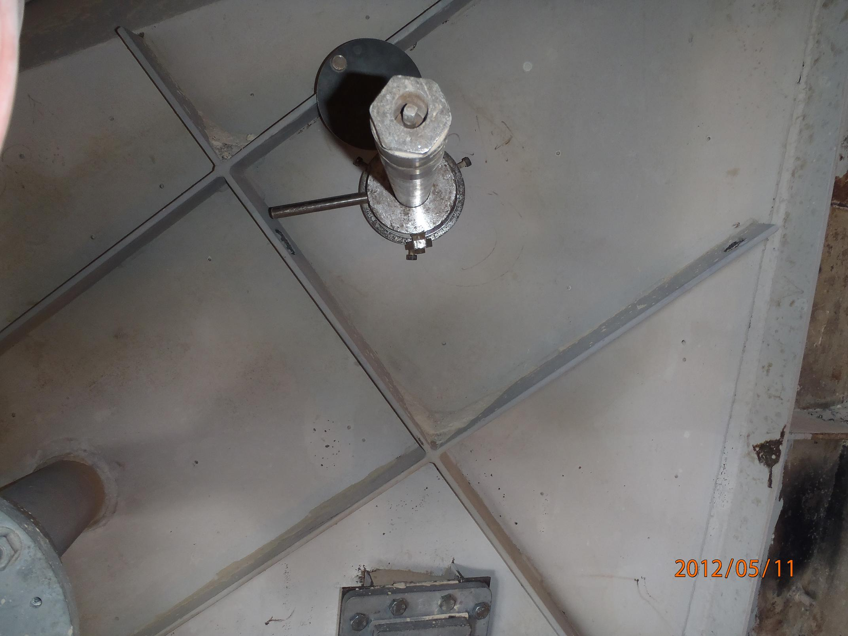
Normal Cardox port with Cap in place Cardox unit attached to port
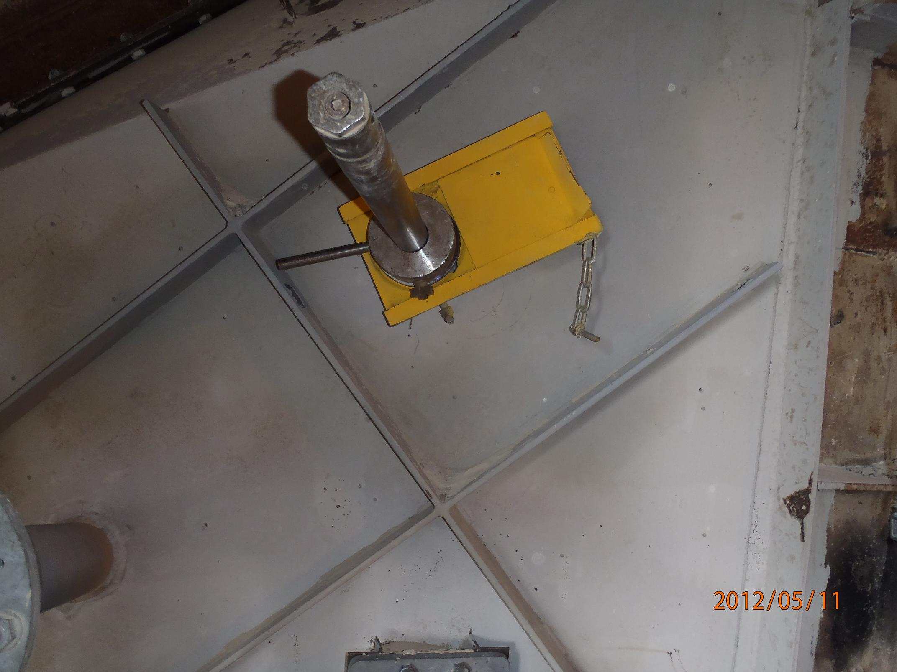
Cardox unit in place with new safety device fitted

