Topic  (Brief guidance on Page 5) Tick or mark ‘X’ in ONE box only  Your company can submit a maximum of 10 entries, preferably no more than two per Topic | Occupational Good Health
 | LGV’s and all company vehicles; Driver Safety/Public Safety
 | Contractors Safety
 | Worker Involvement
 | Bitumen; Asphalt; Contract Surfacing:- Promoting Safer Behaviour
 | If your subject fits none of the above, you may enter here | Engineering Initiatives | X
 | If your subject fits none of the above, you may enter here | Leadership; Training and Management Systems Initiatives

Company Name
Unit Name (where entry is) | Singleton Birch Limited
Address for correspondence (including Post code) | Melton Ross Quarries  Barnetby  North Lincolnshire  DN38 6AE
Person To Be Contacted Name | Kye Brown
Email | kb@singletonbirch.co.uk
Telephone Number | 01652 686000 (reception) 01652 686088 (direct dial)

Title of your Entry (100 characters maximum) | Conforming Isolators – Dead or (A)Live there is no second chance

Preamble
A potentially serious incident occurred on-site, maintenance work was to be started on the primary crusher. The crusher was isolated and locked off as per the company isolation procedure, but when the operator tested for isolation the equipment started up.
The incident was fully investigated, and it was found that the isolator handle connecting shaft had broken inside the isolator; this resulted in the contacts not disengaging.

Incident Investigation Results:
- Common Isolation Incidents that have occurred
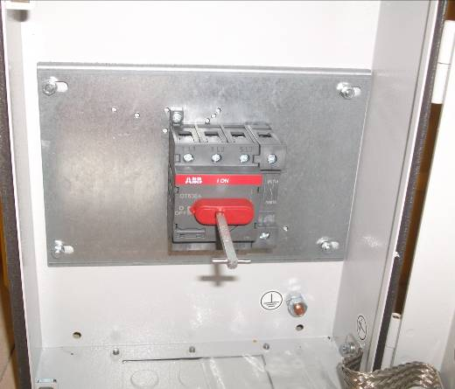
- Failure to disconnect from power source
- Failure to dissipate (bleed, neutralise) residual stored energy
- Accidental restarting of equipment
- Failure to clear work areas before restarting
- Broken or worn linkages,
- Switch failure modes that allow the passing of current in the off position include:
- Welded switch contacts.
- Worn handles that fail to rotate the switch mechanism when the handle is rotated.
- Misaligned handles that fail to engage with the “handle to switch” connecting shaft.

- Potential Hazards
- Automatic and remote starting of equipment
• Failure of components or control systems
• Equipment to be bypassed or overridden
• Failure of isolators
• Failure to identify the correct isolator
• Isolators not provided or not provided in an accessible location
• Pre-start alarms have not been provided or are not effective.

How can we mitigate from potential injury?
- Could we simply get an electrician to check & test there is no passage between the line side and load side of the isolating switch? Yes but;
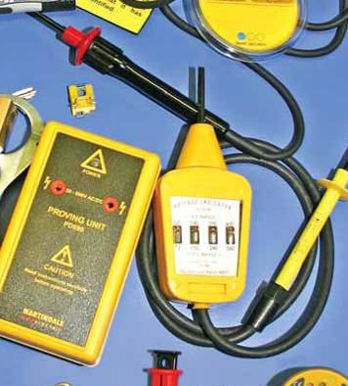
- It is only cost effective on infrequent isolations
- There will be additional costs associated with maintenance team waiting for the electrician to arrive.
- We shall need 24/7 cover.
- It will present maintenance inefficiencies – scheduling difficulties

- Could we simply use an Attempt to start method to verify the isolation? Yes but;
- It does not stress test the isolation switch - Control circuit likely to be inhibited.
- It is inconvenient to use due to interlocks/sequenced control systems
- There could be an inadvertent re-activation of control circuit /interlock would lead to dangerous situation
- There will be complex procedures which change from plant to plant - special and regular training requirements.

- Could we just fit Plug and Socket/Withdrawable switches?
Advantages
- Positive and visual indication that the circuit has been interrupted.
- Simple to use.
Disadvantages
- A protection mechanism required to prevent inadvertent reconnection.
- Not always available or easy to use for large loads
- Easily damaged
- Expensive

Following this review an action plan was developed with the purpose of complying with applicable legislation & guidance
- Provision and Use of Work Equipment Regulations (PUWER) 1998
- Electricity at Work Regulations 1989
- BS 60947 Low voltage switchgear and control gear. Switches, disconnectors, switch-disconnectors and fuse-combination units
- BS 7671:2008 Requirements for Electrical Installations (17th Edition)
- BS EN 60204-1, 2006 Safety of Machinery
- (BS EN 1037: 1995+A1:2008), Safety of machinery – Prevention of unexpected start-up.
- IEC13850 (EN418) Safety of machinery. Emergency stop. Principles for design
And importantly the criteria that compliance with:
Regulation 537.2.2.2 of IEE Wiring Regs (Current Edition) which state that;
“The position of the contacts or other means of isolation shall be either externally visible or clearly and reliably indicated. An indication of the isolated position shall occur only when the specified isolation has been attained in each pole”.

- Outcome – Singleton Birch Specification and Use of Conforming Isolators/Switch Disconnectors for Isolating Electrically Powered Plant Machinery and Equipment: this applies to:
- Local isolators.
- AC circuits only.
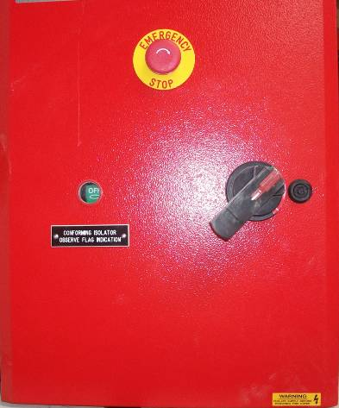
For an Isolator (Switch Disconnectors) to be classed as a Singleton Birch Conforming Isolator it must have additional features to standard off the shelf isolators.
- Shrouding of all potentially live parts to a minimum of IP2X
- Positive opening contacts
- Snap action springs to provide consistent high speed opening and closing but with a positive direct mechanical operation
- Interconnecting shafts are securely fixed by permanent mechanical means, i.e. not grub screws or the like
- Early break screw connection auxiliary contacts
- Enclosure providing protection to IP65
(6 = heavy dust, 5 = Water jet)
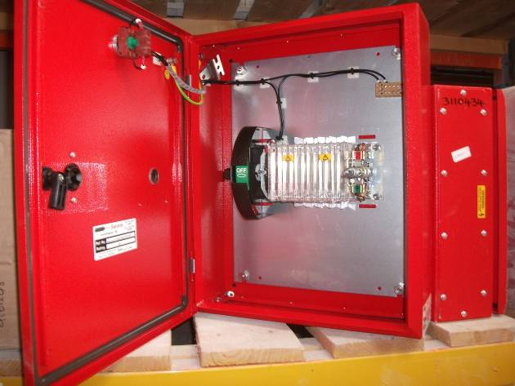
- Non invasive fixings
- Painted Bold colour – Poppy red (BS04E53 Red)

This equipment is backed up by safety working instructions
- These are performed by the staff and checked prior to work order generation (printable with the Work Order)
- Pre-work Risk Assessment – performed by the working party leader and operations Supervisor at the place of work before permission to work is granted (integrated in the Permit to Work)
- Take-2 Minutes – Performed by the working party leader and the team members before carrying out any work detailed on the Work Order (printed on the Work Order)

- Safety Critical Equipment MUST undergo minimum Maintenance requirements
- Maintenance safety critical parts which could fail and cause consequent equipment / protection devices to fail and lead to immediate or hidden potential risks to persons or environment must be considered.
- Functional checks simple tests carried out on a regular basis generally by production and or process personnel.
- Full functional testing to verify the integrity and functionality of all appropriate components combined as a system, i.e. to positively verify that a safety system will function as designed on demand.
- Maintenance and functional check frequencies intervals shall be determined by specific application and associated risk assessment.

Benefits following introduction | - Isolation facilities and isolation/lock-off equipment provided are compatible with each other and are consistent with the documented system of isolation and lock-off procedure  - Provision of clearly labelled electrical equipment, isolators and emergency stops so that they are identifiable as being related to each other  - Control devices are not used as isolators  - Provision of emergency stops in close proximity to isolators and drives to ensure that motor current can be safely interrupted under all conditions  - The system of isolation is constantly monitored  - Close supervision in the workplace and reviewed regularly with input from workers
Photographs with captions (‘before’ and ‘after’ photographs, if possible) Place photographs below for illustration purposes. Attach high quality photographs to email accompanying this entry or ideally apply online via www.Safequarry.com

Before Incident Occurrence
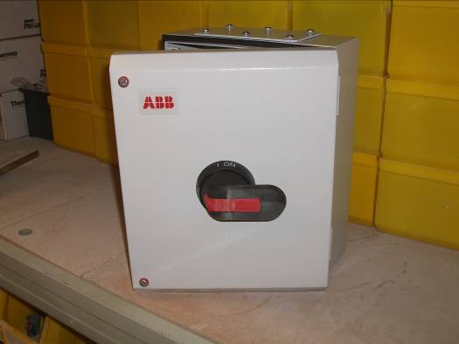
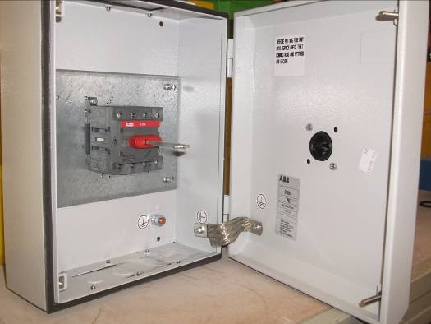

Typical Non-Conforming Isolator (pre incident) - note standard factory colour, no labelling, no flag indicating on or off, signifying positive disconnection

Typical Non-Conforming Isolator (pre-incident) note shaft integrity susceptible to breakage by excessive force

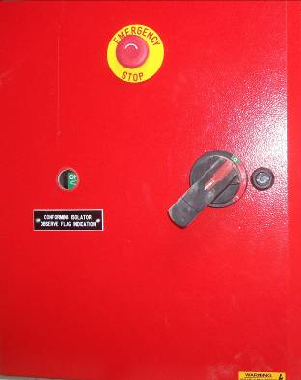
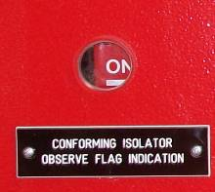
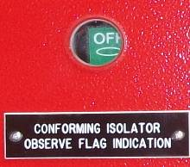
SBL Conforming Isolator (post incident) – note labelling, flag indicating on or off, signifying positive connection or disconnection. Emergency stop button fitted as standard

Post Incident Singleton Birch (SBL) Conforming Isolators

