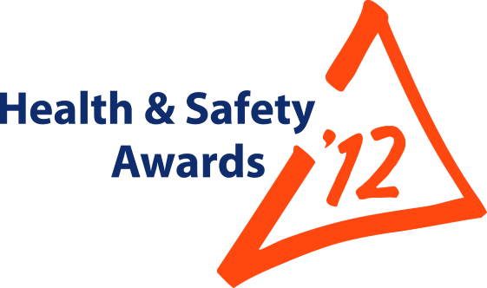


Entry Form

Open to all: MPA members;
non-MPA*companies

* Trophies restricted to MPA members UNLESS,
entry submitted jointly with an MPA Member

Maximum 15 entries per Company

Entry Reference No: |  | For MPA Office use only. You will be advised of your unique Entry Number, to be quoted in any correspondence

Page 2 of 4


Topic  (Brief guidance on Page 5) Tick or mark ‘X’ in ONE box only  Your company can submit a maximum of 15 entries | Occupational Good Health
 | LGVs/HGVs and all other company vehicles; Driver Safety/Public Safety
 | Contractors Safety X
 | Worker Involvement
 | Bitumen; Asphalt; Contract Surfacing:- Promoting Safer Behaviour
 | You may enter here only IF your subject fits none of the above | Engineering Initiatives
 |  | Leadership; Training; Management Systems Initiatives

Instructions | MPA prefers your entry to be submitted online via www.Safequarry.com.  Alternatively, complete this form and attach the form and your photos to an email and send to: hsawards@mineralproducts.org.  BEFORE entering, search www.Safequarry.com for previous similar entries. Your entry needs to be a new idea or a significant improvement of an existing idea.

Company Name | Tarmac West Region and Member Companies of Project 2012
Unit Name (where entry is) | Stancombe Regional Office
Address for correspondence (including post code) | Stancombe Lane, Flax Bourton, Bristol, Avon. BS48 3QD
Person To Be Contacted Name | Rowan Elliott – Regional Operations Director
Email | Rowan.elliott@tarmac.co.uk
Telephone Number | 077205987912

Recognition of Individuals (Optional)  Employees, hauliers, contractors, who have “gone the extra mile” to make this industry even safer and healthier. Person(s) MUST be connected with entry. | John Corcoran – Chepstow International, Jonathan Lewis – Crush Limited, Ian Knott – EPC-UK  Huw Richards – Walters Plant, Howard Austin – Roltech Engineering, Richard Solly – Rema Tip Top  Simon Grey – Response Engineering , Terry O’Callaghan – Kelston Sparkes,  Steve Tubbs – Raymond Brown Group
All representatives of the contractors noted above have been pivotal in making the Contractor Safety Partnership a success.
It should be noted that this entry is made by Tarmac Ltd but on behalf of all participants in the scheme.

Page 3 of 4

Entry Deadline | Thursday 17 May 2012

Title of your Entry | Contractor Safety Partnership (Project 2012)
Following a Medical Treatment Case involving a contractor in 2011, David McClelland, Regional Executive Director West Region discussed with John Corcoran, Managing Director Chepstow Plant International the potential for a West Region Contractors Forum to encourage a better level of engagement and sharing between the Region and its main contractors. Rowan Elliott (RE), Regional Operations Director and Mark Underwood (MU), Regional SHE Manager, were asked to develop this idea.

The underpinning drive behind the partnership would be to use common safety improvement tools, KPI’s and reporting methods across completely independent businesses; all with a common goal of achieving Zero Harm

The format of the partnership can be broken down into the following elements

- Contractor selection and Inclusion
- Vision and Communication Methods
- Safety improvement tools and support
- Common set of reports and Key Performance Indicators

1. Contractor Selection and Inclusion
Nine Companies were selected by RE and MU to be part of the process. The selection criterion was based upon the type and volume of work carried out by the individual contractors for Tarmac West Region.
In essence this group represented the core of the contractor business within the region and although there activities are diverse there links to the region are common.

2. Vision and Communication Methods
The selected Companies were invited to join an initial launch event, hosted by Tarmac and aimed at presenting the vision of Zero Harm, outlining tools for use, discussing KPI’s and formally committing to the Contractors Safety Partnership.
This event, held in September 2011 was followed by a full sign up and presentation event in December at which all participant signed up to their commitment to the process via a charter.
Once signed to the charter members of the Partnership were then invited to a monthly conference call to discuss progress coupled with formal review meetings chaired by Tarmac senior management.
Each member of the partnership was also asked to produce a unique Safety Improvement Plan (SIP). Each individual SIP would be incorporated into a single, common SIP covering the whole Partnership; in this way all goals could be aligned.

3. Safety improvement tools and support
A “Toolkit” of safety improvement tools was developed by RE & MU and presented at the September launch event.
This kit encompasses the core methods Tarmac West Region is utilising to improve safety; these tools were to be considered for adoption by all members of the Contractor Safety Partnership.

The toolkit includes:
- Visible Felt Leadership Tool (Task Auditing). A guide to the use of and instruction in the completion of task audits and effective safety conversations.
- Maintenance Competence assessment. A tool for assessing and improving the skill base of maintenance individuals and teams.
- Supervisor and Maintenance Forums. A tool for providing a unique safety forum for supervisory staff.

Benefits following introduction | - A structured and aligned safety strategy amongst members and a consistent approach to the elements that will help us improve safety.  - Improved safety management of member companies and their supply chain.  - Sharing of incidents and key learns  - Regular and effective communication links  - Support from the HSE  - Common use of safety management tools  - Standard set of safety KPI’s across diverse businesses  - Transparency of and accountability for each company’s current safety performance.  - Sharing of best practice and ideas  - Raising standards in the supply chain.

- HIRA (Risk Assessment). A standardized approach to risk assessment.
- Supply Chain Events. A process to enable contractors to cascade the outputs form the Contractor Safety Partnership within their respective businesses.

These tools were provided in electronic and hard copy for all members of the partnership and training would be provided, where requested, by Tarmac support staff.
The process was also supported and endorsed by local HSE representation.

- Reporting and KPI’s
The final underpinning innovation regarding the Contractor Safety Partnership is the standard adoption and use of reporting and KPI’s.
The Tarmac West Region reporting metrics were presented to the members of the partnership and it was agreed that they would be adopted as standard practice.
These KPI’s include the use of LTIFR (Lost Time Incident Frequency Rate) and TRCFR (Total Recordable Case Frequency Rate). These KPI’s are now being used to manage and improve individual and group performance.

Conclusion

We believe that the Contractor Safety Partnership is an innovative approach to jointly improving supply chain safety performance and targeting Zero Harm. The partnership has been given the title Project 2012 for this year as we aim to influence 2012 contractors via its implementation.

This initiative breaks new ground in contractor engagement and paves the way for broader adoption throughout the industry.

The Charter showing all the companies involved

The Contractor Safety Partnership Charter

Example Key Performance Indicators
Example Safety Improvement Plan (SIP)
The Contractor Safety Partnership Group

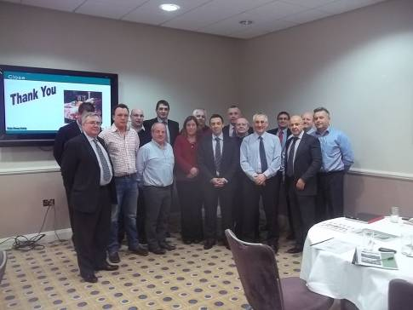

Page 4 of 4

What happens next?

- Entries will be acknowledged; you will be advised of your unique Entry Reference Number which you will need to quote if contacting the MPA, or when making visit arrangements
- Your entry may be switched to another category at the Judges’ ultimate discretion
- Your entry will be read by the appropriate MPA Assessors and Judges who will produce shortlists. The importance of clear description, supported by GOOD QUALITY photographs, is emphasised.
- Judges will visit or telephone shortlisted entrants, where deemed necessary.
- Judges’ decisions are final.

Scheme Rules and Guidance Notes - The 2012 Scheme is open to all
The Mineral Products Association’s annual Awards Scheme is open to all with an interest in health & safety. MPA welcomes entries from every organization in the supply chain. If you are a non-Member and wish your initiative or good idea to be considered for a Trophy, YOU NEED TO ENTER JOINTLY WITH AN MPA MEMBER.

To take advantage of this opportunity via the ONLINE facility, you need to REGISTER on www.Safequarry.com – this will take 90 seconds of your time!
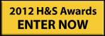

Log into www.Safequarry.com
And click this gold button . . . . . . . . .

. . . . . . . . . . . . . . . . Strict Deadline: 17 May 2012 . . . . . . . . . . . . . .

Points to consider include:  If your Entry is selected for a Judging Visit, the Judge will want to “walk the talk” and discuss your Entry with Operatives, as well as Managers. | - Indicators of commitment by your company
 | - Description of efforts to influence behavioural aspects
 | - Give credit to whoever came up with the good ideas
 | - Effectiveness of control measures (engineering/management)
 | - Method(s) and effectiveness of monitoring system
 | - Problem areas: identification and priorities for action
 | - State actual levels of recorded improvement, if possible
 | - Evidence that existing good practice has been taken on board
 | - Evidence that specific legislation/guidance is understood
 | - Evidence that all relevant workers taken into account
 | - Briefly explain how you communicated the benefits to others
 | - Involvement and genuine workforce support (incl. Trades Unions, where applicable)
 | - Refer to Safequarry.com
 | - Is your good idea/innovation in regular/routine usage?

One of these Scheme trophies could be yours for a year . . .



