EVENT DATE 2010 EVENT LOCATION: UK Site

DESCRIPTION OF THE EVENT AND PHOTOGRAPH(S)
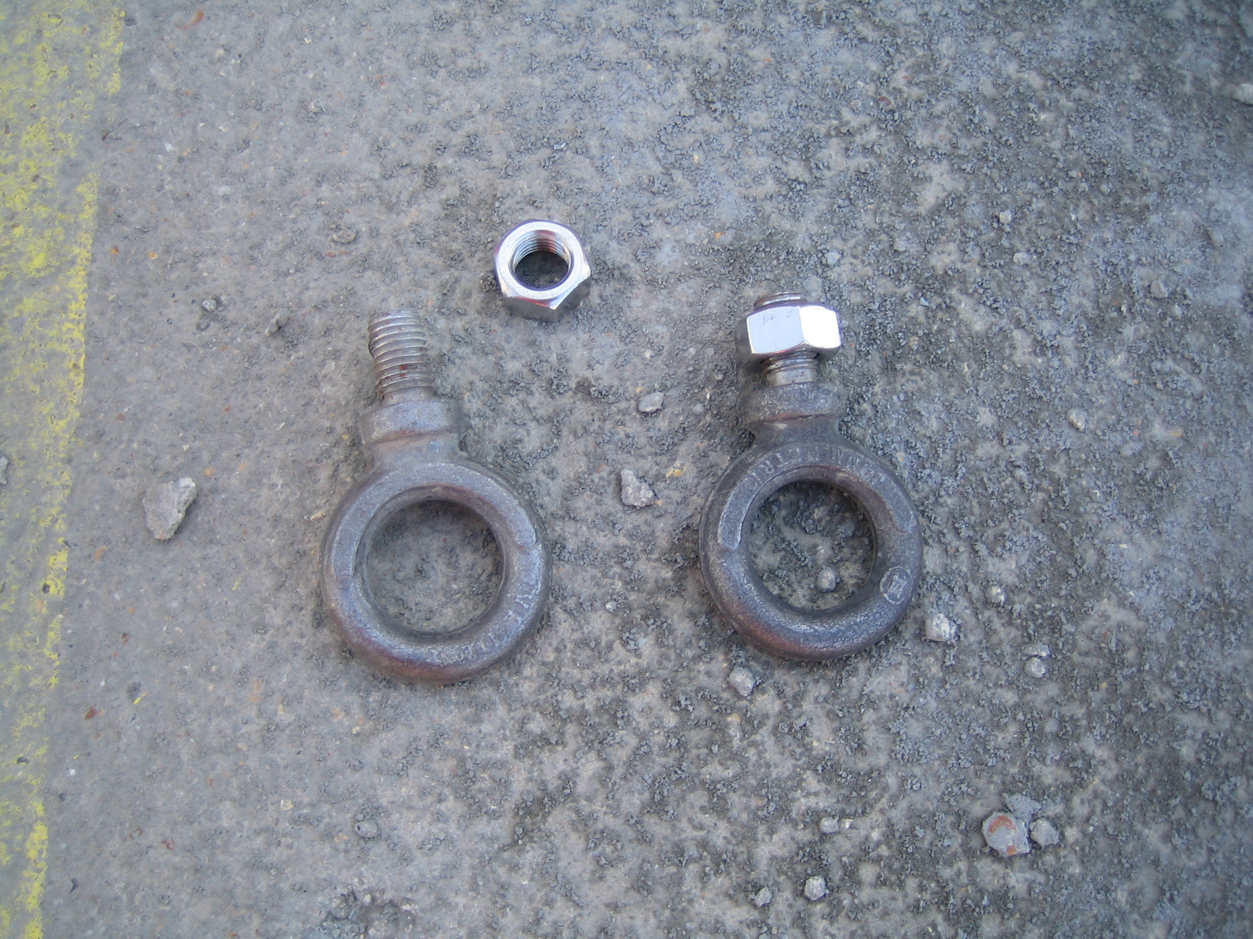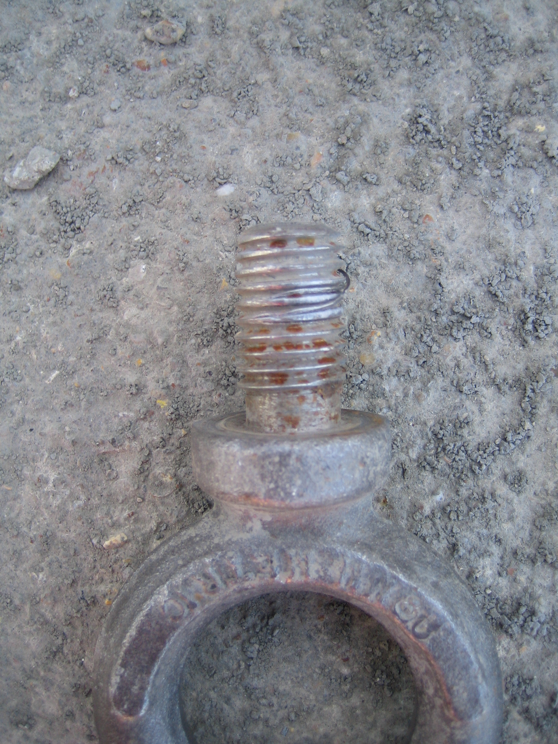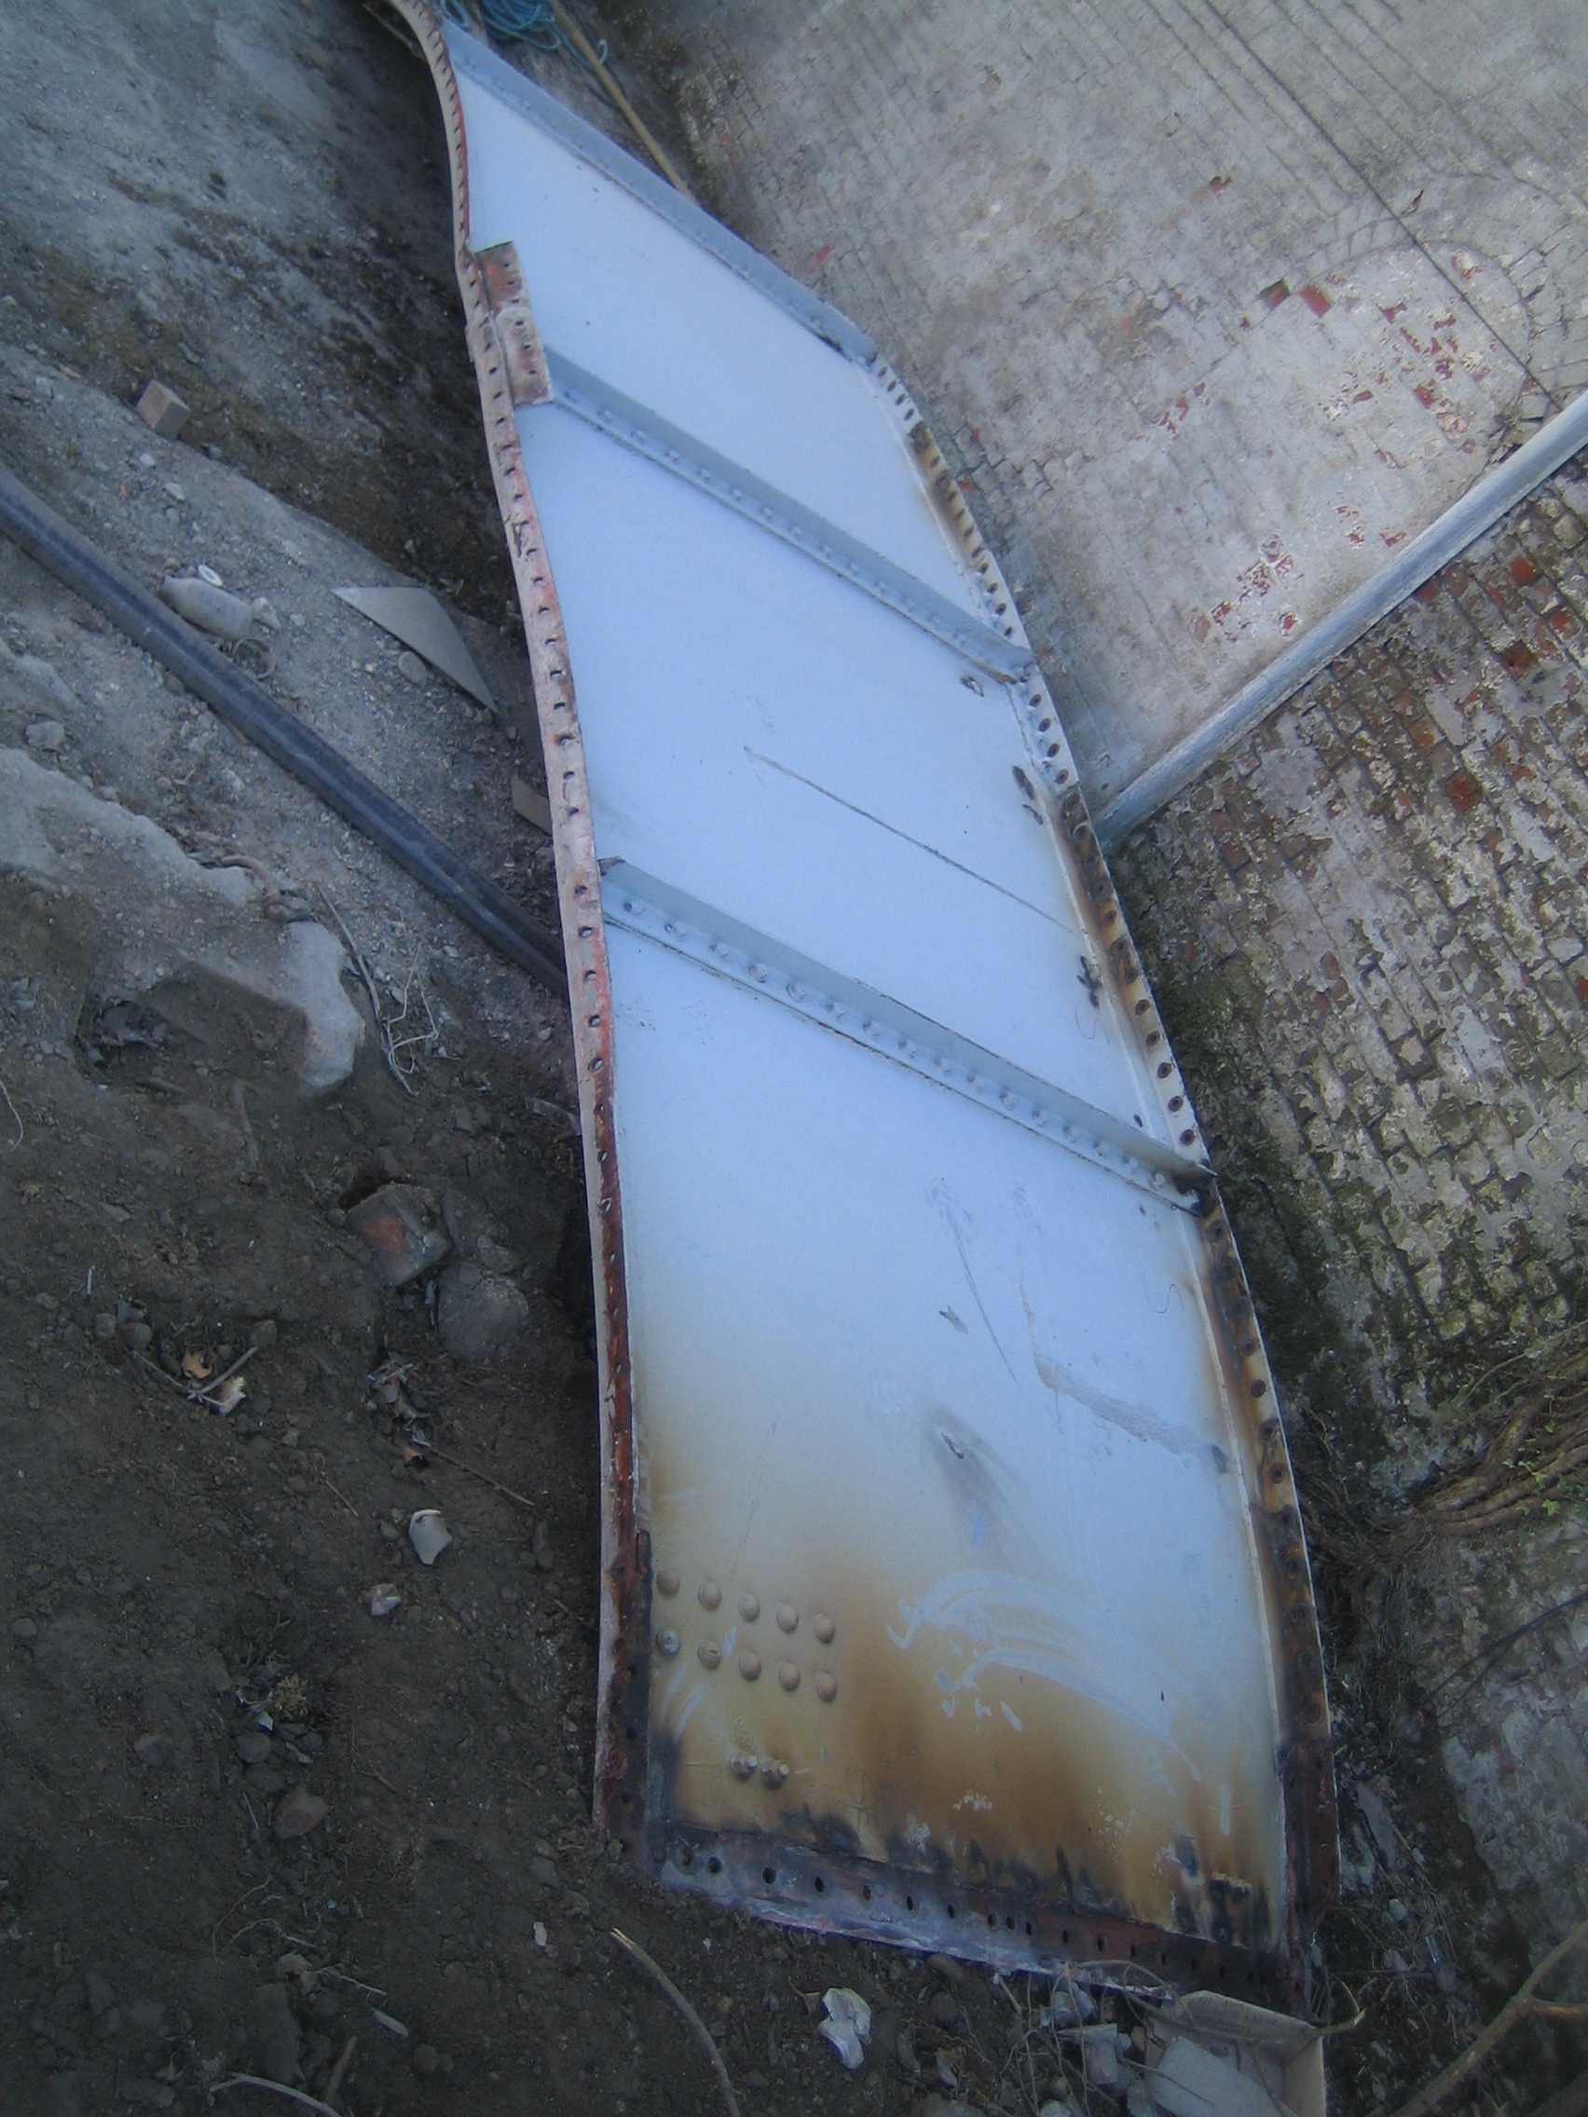

The silo on site was in the process of being dismantled for relocation elsewhere, on lifting down a section of shell plate, the lifting eyes pulled out of their fixing nuts and the plate fell 5 metres to the ground. No persons injured as area no entry to pedestrians during lift.

Initial Notification Contractor notified  Management, task stopped while  Full investigation took place  HSE informed of lifting failure  Reason for failure Mismatch of equipment –  Eyebolts purchased separate from nuts.  Eye bolt sold as size M20 but actually  M18 and Nut purchased M20  Corrective actions Double shackle now used for lift rather  than lifting eyes, risk assessment and  safe system of work and associated  documents reviewed.  Root cause analysis completed  Preventative actions Use double shackle as preferred method | ,  .
Eye bolts and nuts should be purchased together
Check to be completed on Eyebolt size which is
stamped on neck of bolt and slack nuts should be
checked for during rigging operation

Distribution ……

