Topic | Safer maintenance and housekeeping
Entry number (MPA Ref) | 2024130
Title of Entry | Mobile Elevated Work Platform Basket Alarm – Sky Beacon
Name of Company | Tarmac
Location | Tunstead Cement Plant
Video (if yes, please include URL for video) | On request
Other resource X (if yes, please include description) | 2 pdf, images also embedded
Fatal 6 Theme | 3. Work at height
BACKGROUND
- Following the high potential learning event at Barnstone site where a contractor left the basket of the Mobile Elevated Work Platform (MEWP) to access a roof at an approx 6m height, it was recognised that safety around the use of MEWP baskets need to be improved and to deter people from leaving the basket at height in an unsafe manner.
- One of the key points raised from the incident was that the contractor was out of sight and the supervisor could not see the unsafe act.
- This action was the catalyst to come up with an engineering solution to deter MEWP users from leaving the basket and alerting supervisors or personnel in the area that an unauthorised egress of a MEWP basket is taking place.
- The proposed solution called ‘Sky Beacon’ uses a simple light weight lanyard and 140 dBA alarm system which is activated via a ‘grenade type pin’ when the MEWP user moves out of the basket beyondt the length limit of the lanyard when in use.

There is a short demonstration video and presentation available at request for further details.
MANAGEMENT OF PROCESS
- Following this incident, safety equipment providers were researched to see if there was an existing ‘off the shelf’ solution which could be used to manage high risk working at height activities with MEWP, specifically when a person left the basket in an unsafe manner.
- No relevant solution was identified so one was designed with the following basic criteria –

- The alarm system needed to deter the MEWP operator (and passenger) from leaving the basket.
- It must be loud enough to be heard by task supervisors or people in the work location, especially if it was out of view.
- The system needed to be easily attached to the user.
- It needed to be tamperproof.
- It must not hinder or restrict the user in working in the MEWP basket.
- The alarm activates if the user leaves the MEWP basket.
- The system must be easily transferable between different MEWP’s and easily fitted to hire units.

BENEFITS
Use of the Sky Beacon MEWP basket alarm has the following benefits when managing high risk working at height activities.

- Acts as a deterrent to mitigate MEWP users from leaving the basket in an unsafe manner and to STOP and Think.
- Alerts task supervisors if the MEWP user has left the basket in an unsafe/unauthorised manner.
- Extra level of safety for using MEWPs for high risk working at height activities to create a safer work at height environment.
- Easy to use.
- Does not restrict the user in carrying out tasks from the MEWP basket.
- Low-cost solution
- Transferable between different MEWP’s and can be used on hire equipment.
- Can be used in any industry where a MEWP is required.
INNOVATION
Due to the bespoke design criteria of the Sky Beacon MEWP basket alarm, the components required were sourced from different suppliers.

DEVELOPMENT & TRANSFERABILITY
The designed system is a cost-effective solution at under £100 for each system –Note: 2 maybe required for each MEWP to cover driver and passenger so a total of approx. £180 per machine. This is also transferable between machines.
(Prices subject to change)

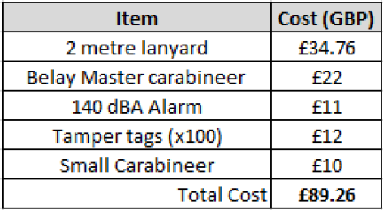

- The proposed Sky Beacon MEWP basket alarm will not stop a person from climbing out of a basket if they are determined but will act as a strong deterrent for unsafe acts which could result in a serious or fatal incident.
- The audible alarm will alert persons in the vicinity that a person has potentially left the basket in an unsafe/unauthorised manner and step in to investigate.
- The Sky Beacon MEWP basket alarm can be used to assist in managing the safety for high risk working at height activities.
- It can be transferred between any industry where MEWPs are being used for working at height activities.
- Any further comments or ideas on potentially taking the design & concept to the next level would be welcome.

NB if document has embedded images try and include these
If other documents provided say additional information available.

