Topic entry (tick boxes that are applicable) 1 2 3 4 X 5 6 7 8
Entry number (MPA Ref) | 22148
Title of Entry | Proximity Warning System (Site Zone)
Name of Company | Hanson UK
Location | Ingleton Quarry
Video (if yes, please include URL for video) | Yes
Other resource (if yes, please include description) | 3 images embedded
Fatal Theme (tick boxes that are applicable) 1 2 X 3 4 5 6
BACKGROUND
In 2019 Ingleton quarry had its static plant demolished as it was uneconomical to maintain. The site then changed to a mobile crushing operation with two crushing trains (Primary and Secondary). Following a risk assessment of the new production process (going from static to mobile plant operation) it became apparent that the existing controls for pedestrians were inadequate.

The mobile crushing plant is based in the centre of a small stockyard. There is regular haulier movement in addition to the two loading shovels and an excavator at all times. (Picture of yard with crushing train below).

Crushers and screens were moved out of line regularly for maintenance and to make cleaning up spillage easier. All this meant it was impossible to install suitable pedestrian walkways for our fitters, technicians, and anyone else who may be required to enter the working area.

Site Zone’s proximity warning solution is used to complement other existing health and safety controls and in ensures that our employees and contractors have a safe working environment, whilst operating around the crushing plant and stock yard area.

Site Zone creates a 5-metre exclusion zone around our machines. If a transponder tag, which is worn on all pedestrians’ helmets, is detected in the zone then the tag will vibrate. In the cab of the machine a red LED ‘tag present’ light will flash, and an alarm will sound warning both operator and pedestrian of their close proximity.
(Site Zone system in our FEL and a correctly worn transponder tag pictured below).

Site Zone will work through walls and around corners. Anyone that comes onto site at Ingleton now receives a Site Zone training video as part of the site induction and are given their own Site Zone Tag.

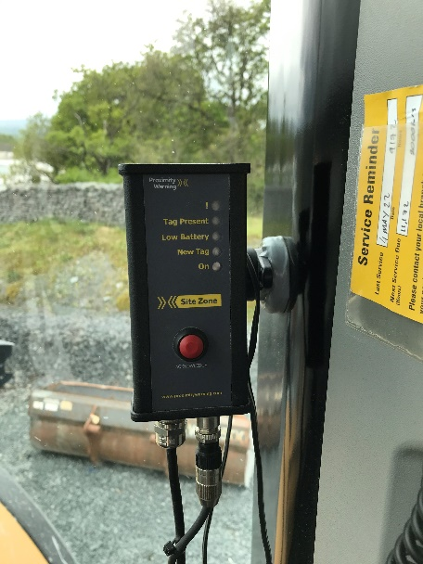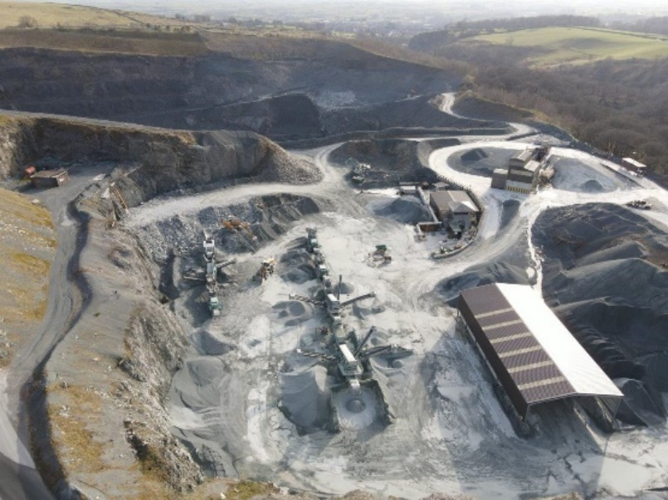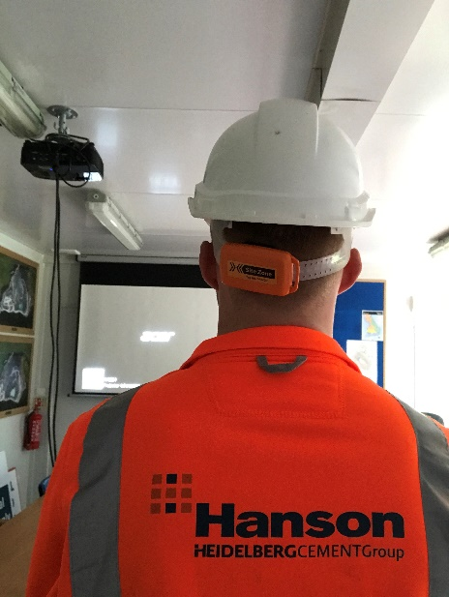
MANAGEMENT OF PROCESS
Site Zone personnel attended site and fitted a trial system to our loading shovel which demonstrated to Hanson the benefits of the proximity warning system in our operation.

We received a quote for what we required on site, this included the Site Zone system that was fitted in to the machines, transponder tags for pedestrians and tag test stations.

Site Zone systems were fitted to both our two FELs, two face dumpers, and our ADT stock dumper, we also had this fitted to the contract crushing teams FEL. The risk assessment that was carried out identified which machines required the Site Zone system.

Both mobile plant operators and fitters are very pleased with the system and how it works. Fitters certainly feel they are safer doing pre-start inspections and working in and around the mobile crushing plant.

All employees on site were given formal training on how to activate and use the system. Site management issue every machine with their own training guide. The is replicated for any new contractor that is required to cover holidays etc or any other personnel that are new to site.

BENEFITS
Sites that have limited space, a small footprint, and high mobile plant movement, such as Ingleton are highly suitable for a proximity warning system.

Site Zone is a very useful tool to improve the safety of pedestrians where compete segregation from mobile plant and walkways is not always possible.

There is clearly a greater alertness amongst both drivers and pedestrians whilst the Site Zone system is in place.

Whilst Site Zone offers visible and audible reminders to both pedestrians and operators, it has also created a culture whereby pedestrians and operators have increased radio contact and a more aware to each other’s position/location further increasing the safety of everyone on site.
INNOVATION
Ingleton was the first Hanson quarry that implemented Site Zone. The site does have other control measures in place to maintain pedestrians’ safety in other areas, however not all of these are possible to achieve at Ingleton due to the restricted footprint of the mobile crushing area.
DEVELOPMENT & TRANSFERABILITY
Site Zone is commonly used in the rail and recycling sector, however, there is a much larger scope to implement this type of proximity warning system within the mineral extractives industry.

The system that has been implemented at Ingleton has been shared internally and significant interest has been shown by the cement side of the business.
NB if document has embedded images try and include these
If other documents provided say additional information available.

