Entry Reference No: | 88 | For MPA Office use only. You will be advised of your unique Entry Number, to be quoted in any correspondence

Company Name | Midland Quarry Products
Unit Name (where entry is) | Cliffe Hill
Address for correspondence (including post code) | Midland Quarry Products  Leicester Road  Whitwick  Leics. LE67 5GR
Person To Be Contacted Name | John Bell / david gazzard
Email | John.bell@mqp.co.uk/dave.gazzard@mqp.co.uk
Telephone Number | 07912 596607 / 07968 544064

Title of your Entry | Reducing asphalt surfacing contractor manual handling by structured material improvements

Brief description;

MQP through its ‘sales net’ and customer service advisors listened to contracting customers complaining regards the difficulty in hand laying asphalt materials leading to operatives complaining of more physical effort needed to lay and spread the material.
In order to reduce the manual handling requirements (workability!) for these materials they needed to turn that perception into a measurable and quantifiable figure that could then be improved on by design mix changes.(improve workability for laying gangs)
A small working group of ‘safer by design’ team members with designs supplied by our bitumen supplier (Nynas) for a “workability meter’ had a device built that allowed them to measure forces required to move their ‘as produced” materials’.
A test protocol was set up and materials were assessed for their workability (degree of effort needed to lay the material), adjustments made and further tests carried out to determine effect.
In conjunction with this in house testing and improvement an external site specialist was contracted to carry out customer site visits to rate the materials in terms of manual handling (effort to lay) and quality and to feed back customer (laying gangs) opinion/perceptions.

Benefits following introduction | - The program of work has logged over 1000 samples and included over 250 site visits.  - It has resulted in reduced manual handling (improved workability for laying gangs) across its product base and increased positive perception regards product handling from its customers.  - A database with graphs showing progress has allowed us to focus on individual products for continual improvement. A record including photographs of each visit is kept, summarized and discussed weekly with Head of Technical , Operations and Commercial Directors in attendance as well as Unit Manager, Site supervisor and Senior Techs to decide on area of focus and advancement.  - A further meter is currently being fabricated to use in other areas including for site visits to embed the process across the company.
Photographs with captions (‘before’ and ‘after’ photographs, if possible) Place photographs below for illustration purposes. Attach high quality photographs to email accompanying this entry or better still apply online via www.Safequarry.com

As well as the attached documents/photographs we have available a video of the apparatus in action, daily records and databases, individual site visit documents and photo’s as well as summaries which although confidential in nature can be viewed should it be required.

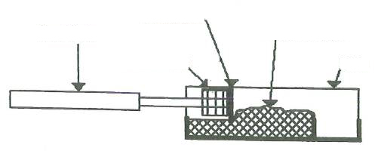
Caption: Workability Meter Drawings from Nynas

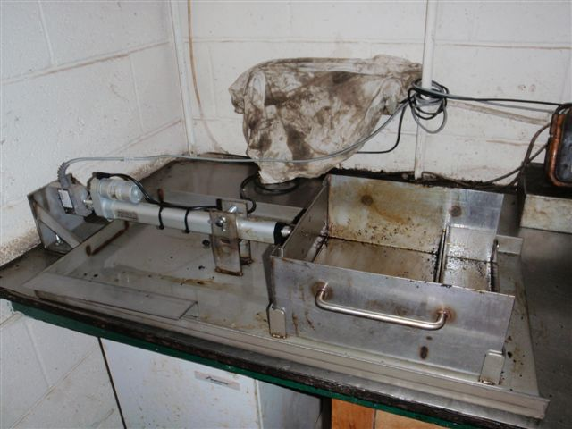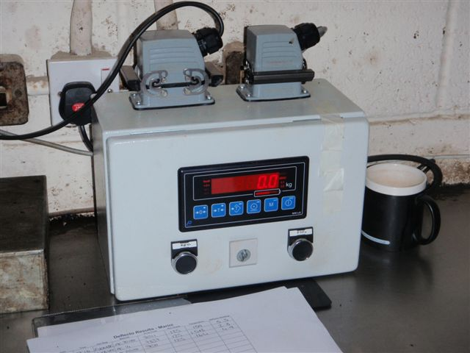
Caption: Workability Meter Apparatus
Caption: Workability Meter Readout

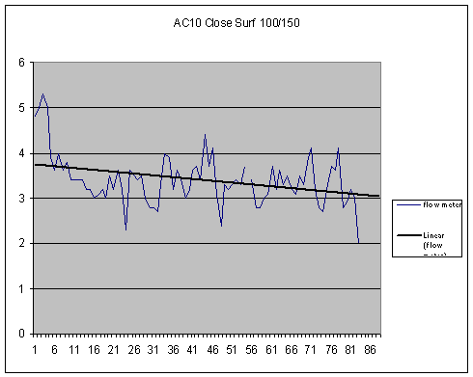
Example of workability results – lower the number the less force required to manually handle
Independent material rating from customer visits (out of 10)

