Health & Safety
Awards 2013

Theme: Entry 143 – Hanson Formpave
Supporting images

Picture showing new plastic curtains added to warehouse main entry
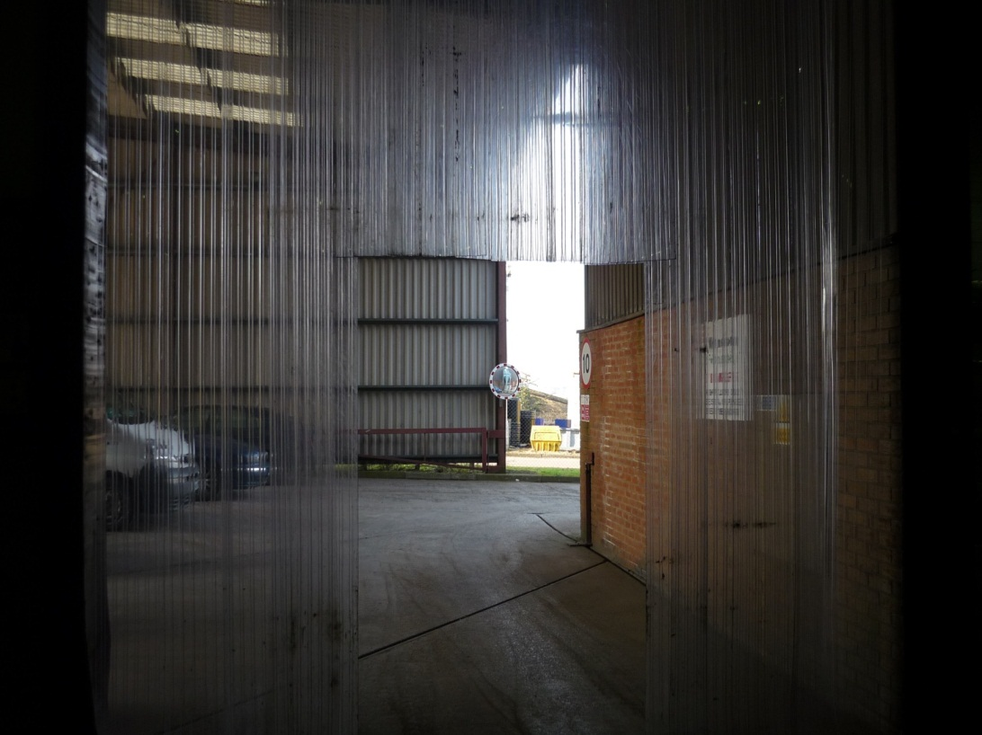

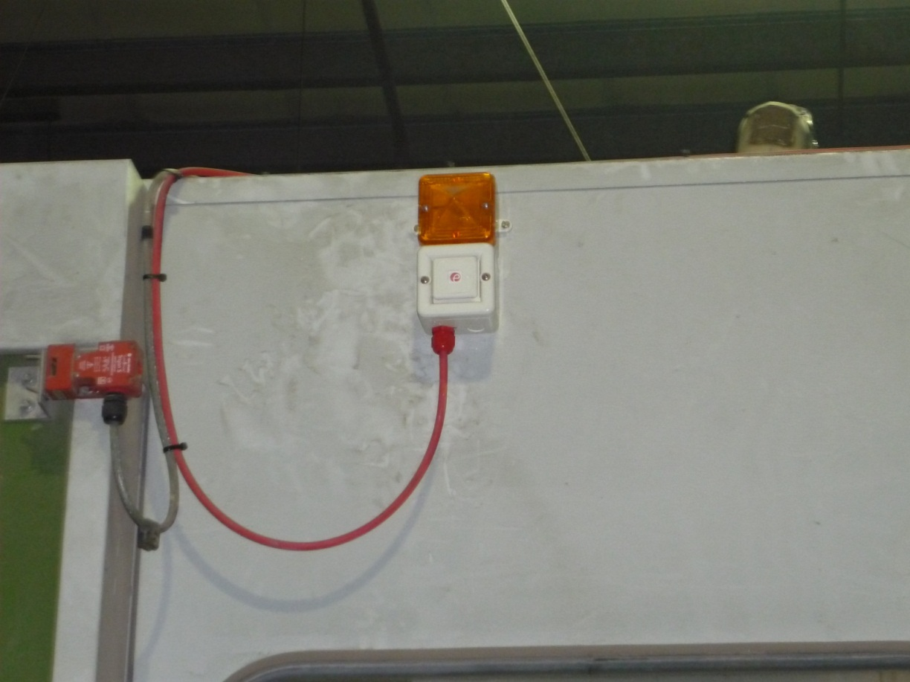

Picture showing installation of visual beacon in Hanson Formpave’s warehouse

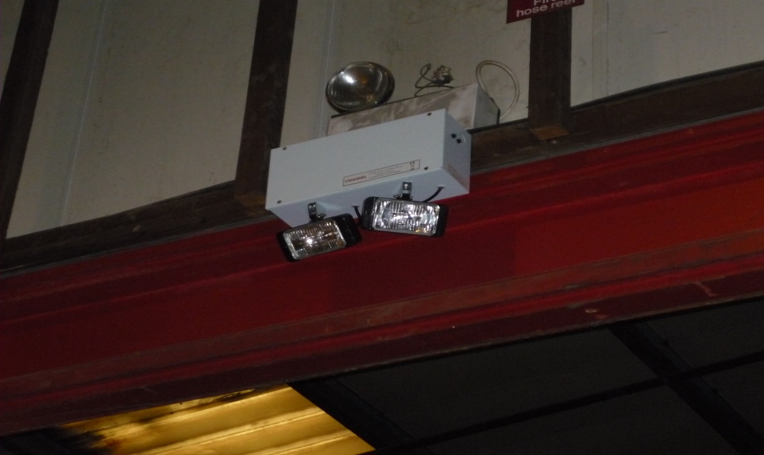

Pictures showing emergency lighting upgrade in warehouse
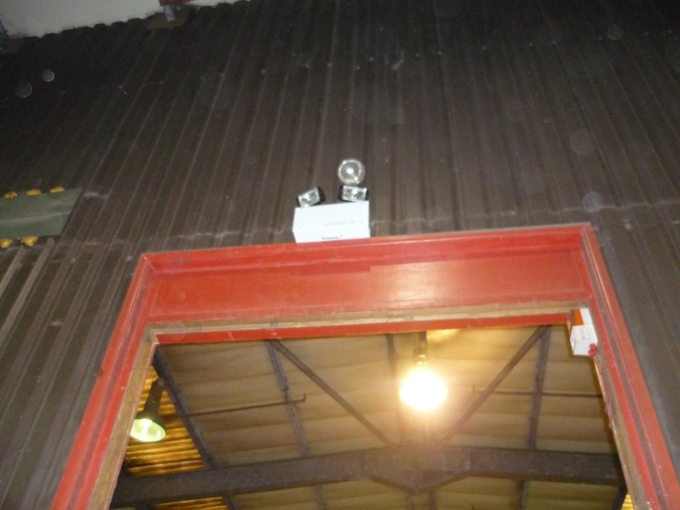

Picture showing upgrades to emergency exit lighting
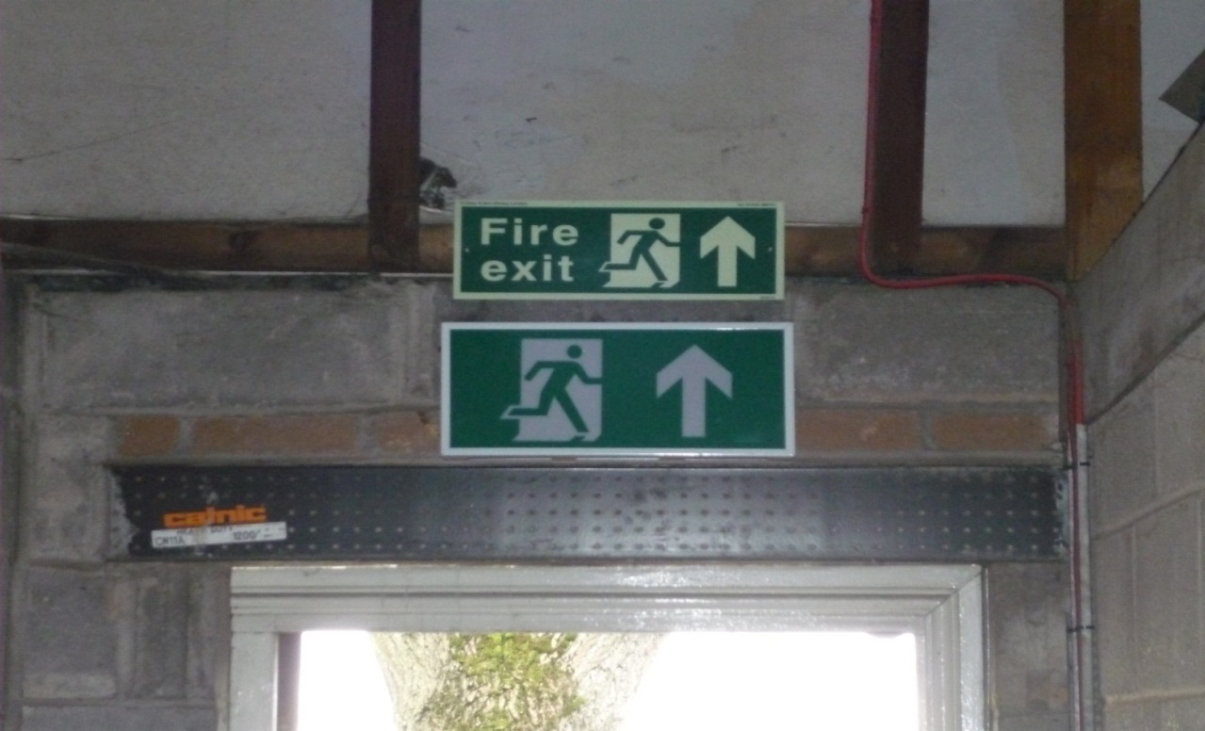

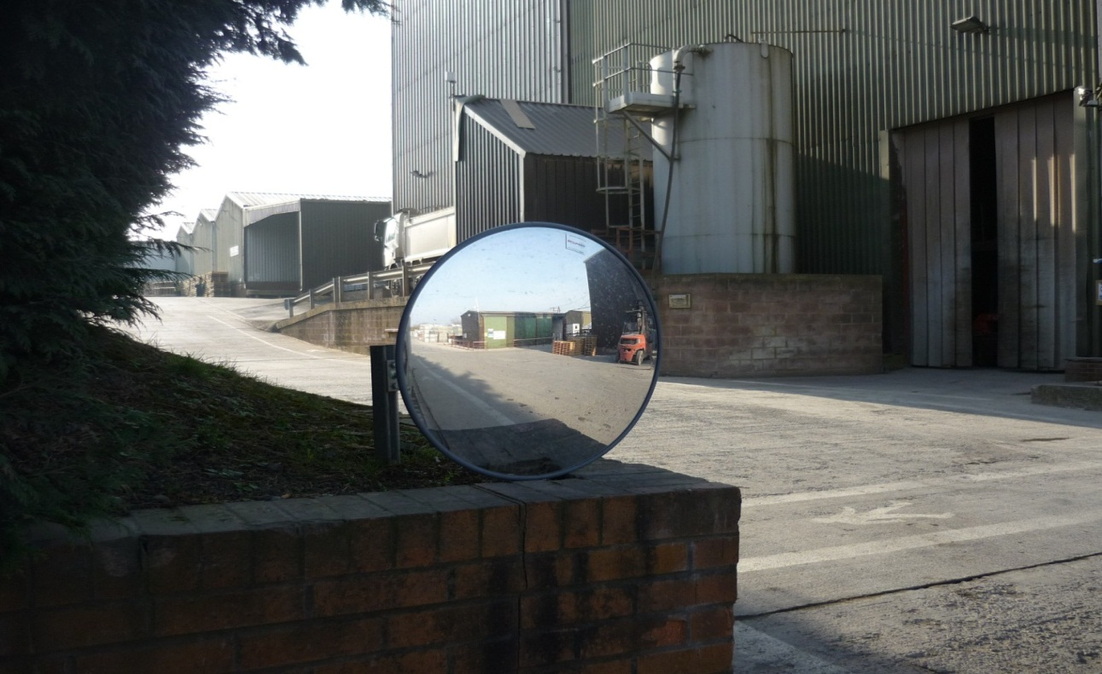

Picture showing additional concave mirrors added to site

Picture showing control stations for both fire alarm systems for the deaf and lone worker alarm

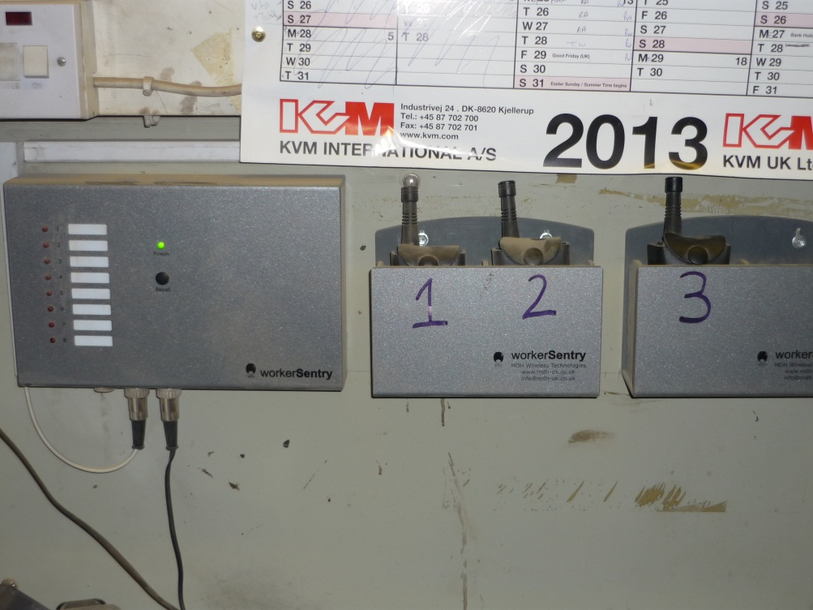

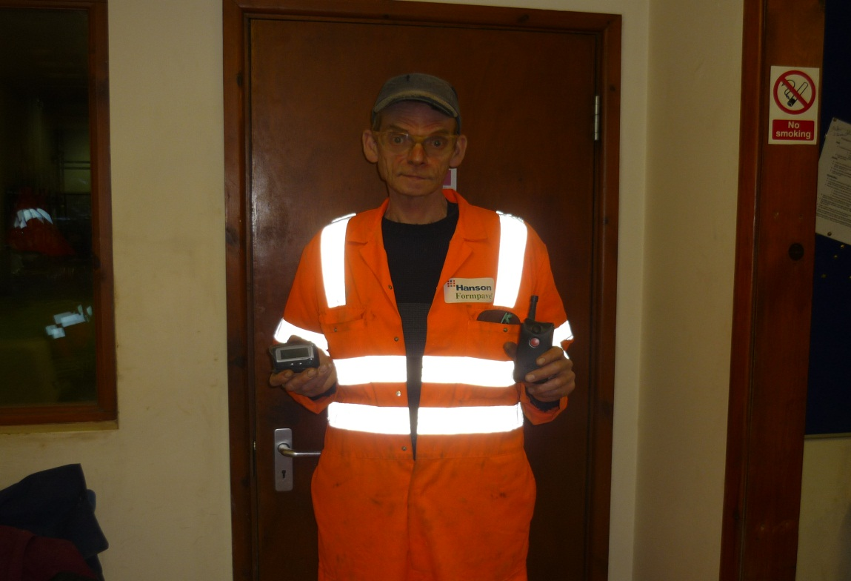

Picture showing employee with fire alarm system for the deaf and lone worker alarm

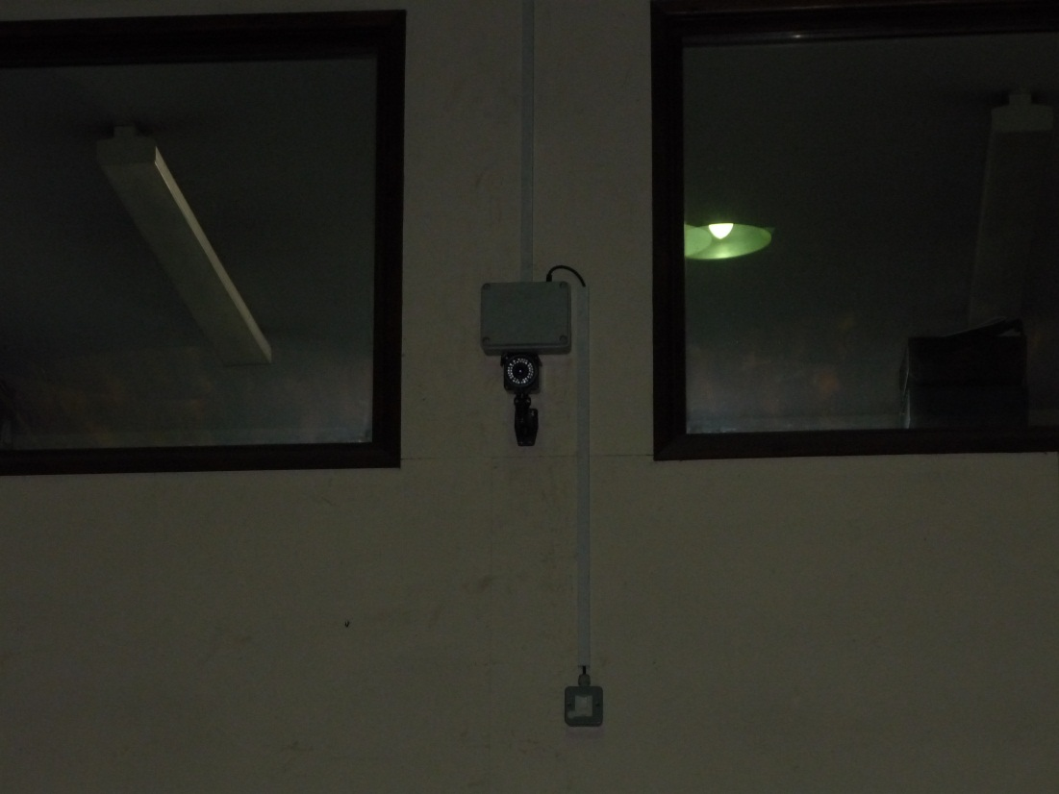

Pictures showing examples of CCTV upgrades on site.

