A briefing tool for managers
Personal Protective Equipment (PPE)
Regulations require PPE; for example, safety helmets, safety footwear, gloves, eye protection and high-visibility clothing, to be supplied and used at work wherever there are risks to workers’ health and safety that cannot be adequately controlled in other ways.
The Regulations require PPE to be:
- properly assessed before use to ensure its suitability for the work being done;
- maintained and stored properly;
- provided with adequate instruction on how to use it safely; and
- worn correctly by the user.
provided with adequate instruction on how to use it safely; and
- worn correctly by the user.

A truckmixer driver slipped and stepped backwards into slurry and as a result, his trousers and boots became soaked in concrete. The driver had no clean trousers to change in to so he cleaned off his trousers and boots as best he could. On arriving home the driver’s legs became sore and after seeking medical advice he was informed that he had sustained cement burns.
This incident emphasises the need to wear overalls and have spare clothing available.
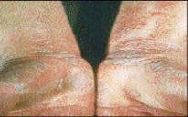
Example of cement burns to hands/wrists
A contracted haulier was struck by a reversing fork-lift truck after leaving the cab of his vehicle. The result of this collision was that the driver sustained significant leg injuries and had subsequent surgery to pin lower leg and ankle fractures.
The main causes were the operator of the fork-lift not seeing the driver whilst reversing and the driver NOT wearing hi-visibility garments (PPE).

An operator was exposed to a flash fire when a LPG cylinder fell resulting in the fracture of a fitting between the regulator and hose causing a leaking gas flame.
The operator attempted to turn-off the LPG and sustained burns to his face, neck and arms requiring immediate treatment at a nearby hospital. The Eye Protection worn by the employee prevented his eyes from being damaged as can be seen from the picture below where you can see the area of his face that was protected.
DRIVER SUFFERRED CEMENT BURNS

EMPLOYEE SIGHT SAVED BY SAFETY GOGGLES

HIT BY FORKLIFT – NOT WEARING HIGH VISIBILITY CLOTHING

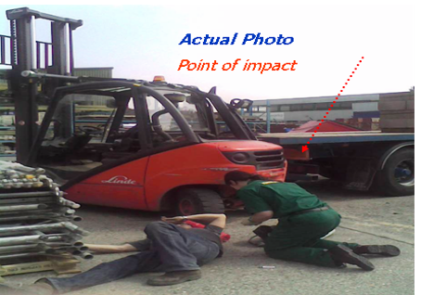


Personal Protective Equipment (PPE)
Preparation
This stop and think talk can be used individually or with a group employees or contractors. It may be beneficial to have samples of the various PPE to hand to show what is required and the standard expected in terms of condition (cleanliness, compatibility etc.) Participants should receive a copy of the talk for their CPD files as well as signing the training declaration.

Introduction (After discussing the case studies)
Personal Protective Equipment is a last line of defence but is essential in the building materials industry due to the nature of hazards encountered. PPE has three roles, it helps prevent accidents, such as wearing high visibility clothing, helps reduce the potential for injury when an accident occurs, such as safety helmet protection from falling objects and safeguards health, as in the case of respiratory protection i.e. dust masks.
Improvements in the type of PPE worn and changes to the policy have in recent years prevented the injured parties in accidents from sustaining far worse injuries than would have been the case previously. For example replacing Rigger type boots with lace up safety boots reduced ankle/leg injuries by 64%, mandatory eye protection resulted in a 75% reduction in eye injuries. There are number of people who have worked for the business who have these policies to thank for being able to walk unaided and for still having their sight.
Effective PPE

Question 4 – What are the key points in making sure PPE is effective?

Correct specification and size

Suitable storage facilities

Equipment is maintained and replaced as necessary

Regular inspection

That it is worn correctly

Types of PPE

Question 5 – What protective equipment do you use? Can you identify other PPE besides the common items listed?

Helmet

Laced up ankle boots

Hi visibility clothing

Safety glasses

Gloves for manual work

Hearing protection for work in noisy environments

Dust masks

This might be an opportunity to review PPE participants have with them to highlight if any needs replacing. This talk could be done in conjunction with a periodic inspection of PPE.

AND FINALLY . . .

1. Clarify any points as required.

2. Ask if there are any other safety related issues that should be discussed.

3. Get everyone to sign the training declaration.

4. Thank everyone for their participation.

What is PPE

Question 1 – What is the definition of PPE?

All equipment which is intended to be worn or held by a person to protect against one, or more, risks to health and safety

This includes clothing which affords protection against the weather

Employer Responsibilities

Question 2 – What are the Employers responsibilities?

PPE must:
- Be appropriate for the risks involved & conditions at the place of exposure

- Take account of ergonomic requirements & state of health of wearers

- Be capable of fitting wearer correctly

- Be effective in preventing or controlling the risks

- Comply with any EC requirements

Employee Responsibilities

Question 3 – What are your responsibilities?

To co-operate with the Employer

To wear PPE in designated areas

To report defects and request replacement PPE as necessary

To use the PPE correctly

To correctly store and maintain the PPE

To report loss or obvious defects in the PPE to employer
THE TALK
Use the Questions below to open the discussion under each heading and then go through the lists explaining in detail each hazard/control and what is expected.

Personal Protective Equipment (PPE) – Training Record

The people listed below have received instruction in Personal Protective Equipment as detailed on the previous pages. By signing below they are confirming that they understand the responsibilities discussed and will adhere to CEMEX policy on PPE in the workplace.

Date | Name | Signature | Instructed by

